The IoT Weather Station Model

Dragan Kreculj¹, Senior lecturer; Vojkan.Nikolić², Assistant professor; Jasmina Lozanović Šajić³, Senior Research Associate; Đorđje Dihovični⁴, Professor of vocational studies; Nada Ratković Kovačević⁵, Professor of vocational studies

¹Academy of Technical Vocational Studies, Belgrade, SERBIA, dragan.kreculj@visokatehnicka.edu.rs
²University of Criminal Investigation and Police Studies, Belgrade, SERBIA, vojkan.nikolic@kpu.edu.rs
³Innovation Center of the Faculty of Mechanical Engineering, University of Belgrade, jlozanovic@mas.bg.ac.rs
⁴Academy of Technical Vocational Studies, Belgrade, SERBIA, dihovicni@visokatehnicka.edu.rs
⁵Academy of Technical Vocational Studies, Belgrade, SERBIA, nada.ratkovic.kovacevic@visokatehnicka.edu.rs

Summary: Meteorologists use special devices to measure and read weather parameters. Over time engineers have tried to realize the highest quality devices, that are efficient, easy to use and lower prices. In this paper the mobile IoT system is considered, designed and then implemented. The proposed technological solution – weather station model, consists of the following elements: ESP32 microcontroller, DHT22 sensor, BMP180 sensor, MQ135 sensor, Arduino protoboard (cables). The data transmission channel with used equipment and via enabled Wi-Fi connections is realized. Obtained data from specific sensors to the Blynk application were distributed with the task to monitor and analyze weather parameters (temperature, pressure, humidity, CO₂) over powerful cloud software platform. The appropriate codes for the created project was written and then in real conditions tested. The listed model presents an applicable multifunctional approach based on electronics, automation, computer networks, programming.
Key words: IoT, weather station, sensors, microcontroller, Blynk application.

1. INTRODUCTION

Innovations in technologies often based on controlling and monitoring of different devices wirelessly over the internet. The Internet of Things (IoT) present the network of physical devices that are embedded with sensors, software and other technologies for the purpose of connecting and exchanging data with other devices and systems over the internet. The IT give education professionals relevant tools to optimize work in classes, improve the efficiency of learning process, better connect teachers with students and notably ensure safety. These approaches are especially characteristic for technical group of teaching subjects.
Weather data are continuously changeable and subject of numerous investigations in everyday life and work. Over time, better technical solutions are sought to collect and distribution weather parameters. Meteorological data can be obtained automatically by special professional systems and devices from the meteorologists.
In this paper the example of weather station realization with using ESP32 controller, DHT22 sensor and Arduino protoboard is presented and discussed. The device can constantly monitor the ambient (inside, outside) temperature, humidity, GAS and pressure by using special electronic equipment connected to the cloud platform.
The weather station is an instrument or device, which provides measure of weather information in atmosphere. Streaming data consist of details about the surrounding temperature, barometric pressure, humidity, light intensity, wind (strength and direction), rain value etc.
Today it is possible to make small and not complex weather station model using existing available elements, devices and appropriate software. They are ready almost to completely replace the professional ones, but also are efficient and cheaper.
The main elements of the smart weather station are:
- Network for communication - wire, cable (LAN), wireless;
- Intelligent control system - microcontroller to manage the system;
- Embedded sensors - devices which can be used to observe and measure ambient parameters. [1]
In technical schools specific course, as electronics, automation, mechatronics, computer science, are studied from the theoretical and practical aspect of view. Affordable, powerful devices and systems can be used to perform and implement the multidisciplinary classroom approach and project teaching. Thus students will be involved in the development of visible systems, that also have use value and significance for local and national community and potentially economy activities.
Researchers assume that further development of such meteorological devices will be in the form of simultaneous data sending from several smart weather stations distributed locally, all at the same time and to the common united communication channel. [1]

2. OVERVIEW OF BLYNK APPLICATION

Blynk is an IoT software platform designed for faster and easier remote reading and management of data obtained from sensors set to various modern devices. Blynk itself seeks to eliminate the need for encryption and facilitate access to devices from anywhere (only with internet connection) via computer and smart phone. The free option is available to hobbyists and developers, while with commercial option fee some subject can create own applications and systems, and then even sell them on a market.
Blynk is a special platform compatible with very popular iOS and Android smart phones (see figure 1). It can communicate with various microcontrollers (e.g. Arduino, NodeMCU, Raspberry Pi, Beaglebone Black, Particle Photon, etc.). It is designed for internet content and can remotely control hardware and stored sensor data for any desired project. This application is ideal for people who do not have the knowledge level required to create a complex mobile phone application, or who need prototypes quickly.

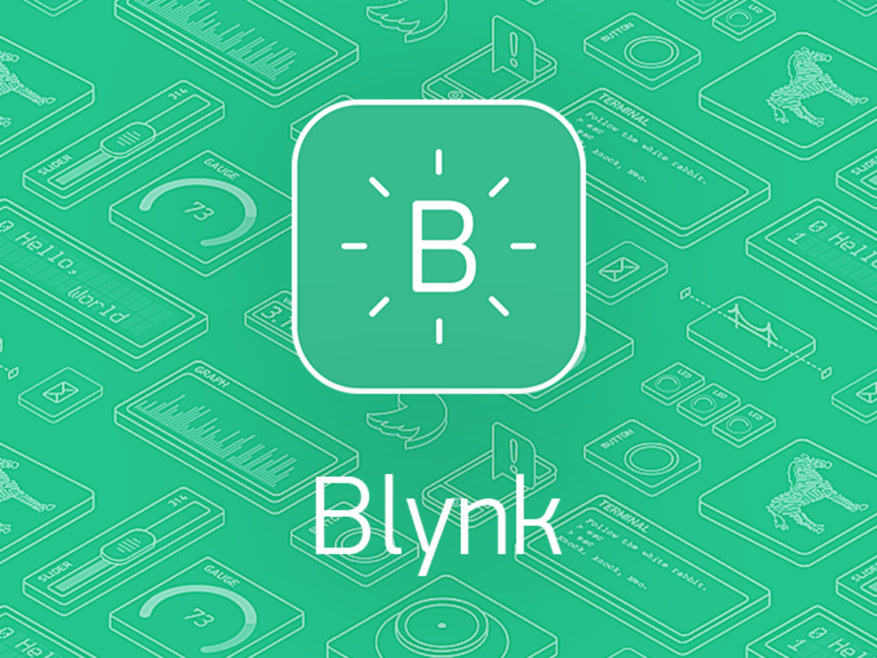
Figure 1: Blynk Application

By using the Blynk IoT application, all relevant information can be easily accessed. It is about transmission of information dataflow by some wireless connection to Blynk, after that they are stored in some own database. Then appropriate added analyzes with collected data can be fully executed with special software tools. [2]
Blynk was designed especially for the IoT systems. It can control hardware remotely, display sensor data, store data and visualize data. There are three major components in the platform:
- Blynk App, allows to create amazing interfaces for projects using various provided widgets.
- Blynk Server, open-source responsible for communications between the smart phone and hardware, it can be used Blynk Cloud, or private Blynk server locally.
- Blynk Libraries, for all the popular hardware platforms enable communication with the server and process the input and output commands (figure 2). [3]

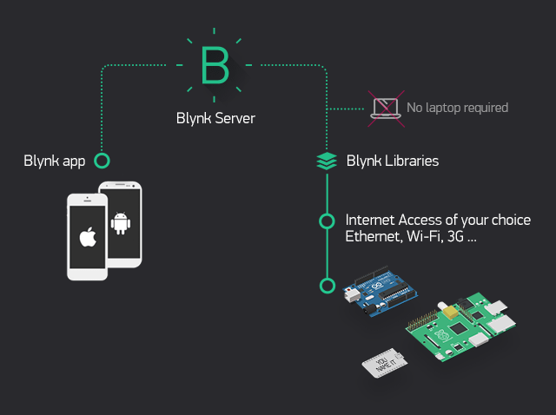
Figure 2: The Blynk apps principle of functioning

Blynk application uses its own server and library to deliver consumers adequate services. Application is a free and available on Android and iOS operating systems. It is characterized by a simple drag-and-drop system to build custom controls for the certain IoT project settings.
When a new project is started the development board and the connection method are selected. The application then sends an authorization token via email to connect to the appropriate device over the Blynk server. Controls contain widgets, ie. different types for entering and displaying results, including a button, sliders, joystick, charts, text feedback. Also there are component specific accessories, with stylized controls for LEDs, LCD screens and even live video. [4]
Blynk is constantly being improved by giving more options to users. As a web dashboard is a connected business management application aimed at configuring Blynk services, managing devices, people, companies, and data. Multi-tenancy enable a role-based access system with granular permissions almost for any available action. New visual customization engine allows to easily apply custom look and feel of the mobile apps and web dashboard. Every device has a dashboard to visualize real-time and historical data from sensor and controls. Devices are now independent from the projects, and device tiles is a default component. WiFi connection wizard is included in Blynk apps by default. [5]

3. DEVICES AND EQUIPMENTS

3.1 DHT22 sensor
DHT22 represent a basic, low-cost digital temperature and humidity sensor (see figure 3). Device uses a capacitive humidity sensor and a thermistor to measure the surrounding air and spits out a digital signal on the data pin (so no analog input pins are needed). This makes them very easy to use with almost any microcontroller. Sensor is quite simple to use, cheap, but requires careful timing to grab data. By this sensor it can be obtained new data from every 2 seconds. [6]
It is needed simply connect the first pin on the left to 3-5V power, the second pin to data input pin, and the rightmost pin to ground. For multiple sensors, each one must have own data pin. In comparison to the earlier version DHT11, DHT22 sensor is more precise, operates in a bigger range of temperature and humidity, but also larger and more expensive.
Sensors contain a chip that make analog to digital conversion and spit out a digital signal with the temperature and humidity. Those facts make them very easy to use with any existing microcontroller.

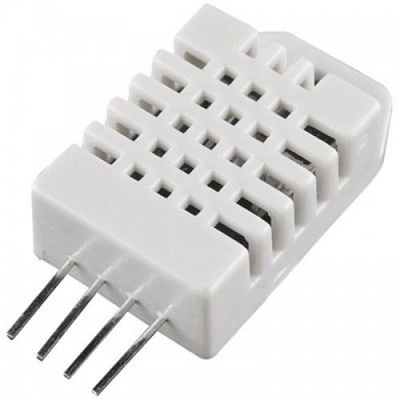
Figure 3: DHT22 sensor

3.2 BMP180 sensor
The BMP180 is the next-generation of sensors from Bosch. Device (figure 4) consists of a piezo-resistive sensor, an analog to digital converter, and a control unit with E2PROM and a serial I2C interface. The BMP180 delivers the uncompensated value of pressure and temperature. That is a high precision low cost sensing solution specially designed for consumer applications, such as weather forecast, sports devices, GPS, computer peripherals, navigation. Sensor can also be used as an altimeter because pressure is changed with altitude. [7]

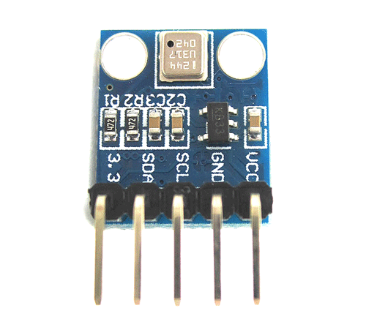
Figure 4: BMP180 sensor
3.3 MQ135 gas sensor
The MQ135 Gas sensor (figure 5) in air quality control equipments are used and for detecting or measuring of NH₃, NO_{x}, alcohol, benzene, smoke, CO₂ is suitable. Similar to other MQ series gas sensor, this sensor also has a digital and analog output pin. The gas sensor module consists of a steel exoskeleton under which a sensing element is housed. The MQ135 air quality sensor module operates at 5V and consumes around 150mA. It requires some pre-heating before it could actually give accurate results. [8]

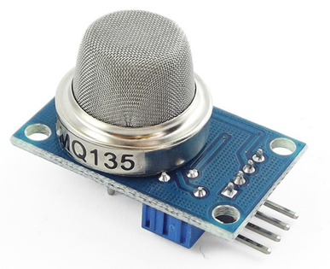
Figure 5: MQ135 Gas Sensor

3.4 ESP32 microcontroller
ESP32 is a feature-rich MCU (microcontroller unit) with integrated Wi-Fi and Bluetooth connectivity for a wide-range of applications in the control systems. A powerful 32-bit microcontroller contains one or more CPU (with LX6 microprocessor), along with memory and programmable input/output peripherals. [9]
The microcontroller ESP32 (shown in figure 6) with the follow unique features is characterized.
Robust Design
ESP32 is capable to operate reliably in industrial environments, with an operating temperature, ranging from –40°C to +125°C. Powered by advanced calibration sets, device can dynamically remove external circuit imperfections and adapt to changes in external conditions. [9]
Ultra-Low Power Consumption
Design for mobile devices, wearable electronics and IoT applications, ESP32 achieves ultra-low power consumption with a combination of several types of appropriate software. Controller also includes state-of-the-art features, as fine-grained clock gating, various power modes and dynamic power scaling. [9]
High Level of Integration
ESP32 is highly-integrated device with in-built antenna switches, RF transceiver, power amplifier, low-noise receive amplifier, filters and power management modules. Moreover it adds priceless functionality and versatility to some applications with minimal Printed Circuit Board (PCB) requirements. [9]
Hybrid Wi-Fi & Bluetooth Chip
ESP32 can perform as a complete standalone system, or as a slave device to a host MCU, reducing communication stack overhead on the main application processor. Then it can interface with other systems, to provide Wi-Fi and Bluetooth functionality through its SPI/SDIO, or I2C/UART interfaces. [9]

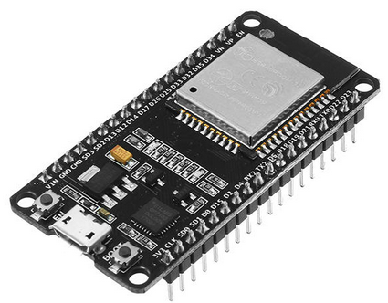
Figure 6. ESP32 microcontroller

The specific code for this teaching project in programming language C was developed (C++ is also suitable for the developers). Complete code is not more complex and only about 30 lines occupies. Codes in accordance with Blynk application and ESP32 allow users to receive weather data updates and wirelessly control the weather station from particular close by mobile device.

4. RESULTS AND DISCUSSION

The shaped project model, formed of ESP32 microcontroller, DHT22 sensor, BMP 180 sensor, MQ135 gas sensor
and subsidiary Arduino protoboard, in the figure 7 is presented. The specific model components in a prescribed and proper manner are interconnected. With the cables, or Wi-Fi established connections, the model of meteorological station has on simply way created and ready to functional use.

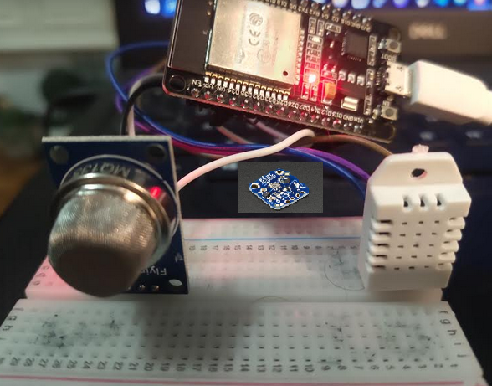
Figure 7. The model of weather station

As a central software intended for monitoring the results of measured weather parameters, the Blynk app were used. For the displaying of collected data from temperature, humidity, gas and pressure suitable widget gauge in app is chosen. Value distributions of key weather parameters, during time in Blynk app, in figure 8, 9 and 10 (over diagrams) are presented. These diagrams originated from 24h time period observing and measuring weather parameters on a certain mobile phone. Thereby reading being performed every second (measure time period).
Databases in meteorology in sets of different data types and values are collected and organized . They are placed in certain compute storages locally, or in the cloud services. The weather parameters in the appropriate formats are frequently available for the end users. Some of them are categorized as open data. They can be used for further statistical analysis in the special software packages. For this purpose, the sophisticated software cloud platforms are of practical importance and consequently real implementation. Machine learning (ML) and Artificial Intelligence (AI) are some approaches for deep and precise considerations and estimations of weather data. Moreover climate and weather influence people health directly through a number of interrelated factors.

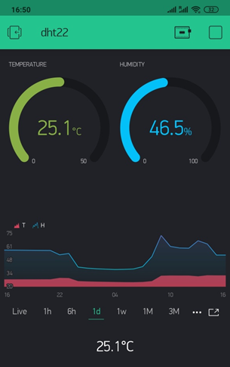
Figure 8. Monitoring of temperature and humidity through time via Blynk
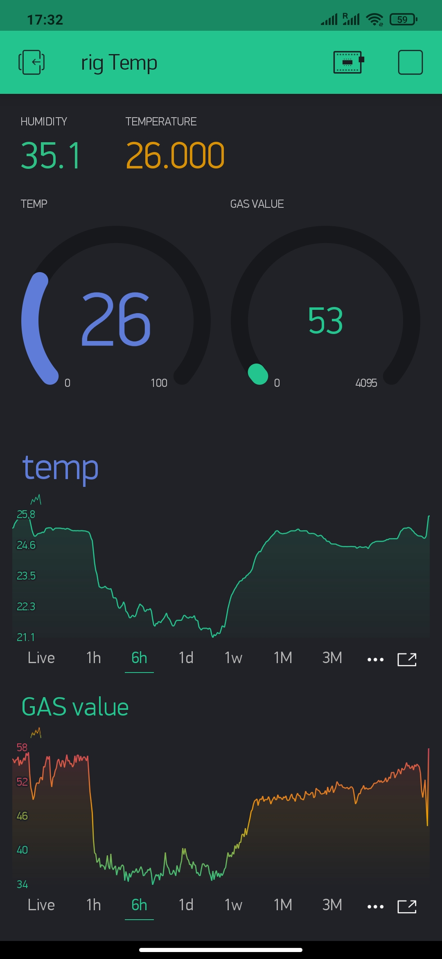
Figure 9. Monitoring of temperature and CO₂ through time via Blynk

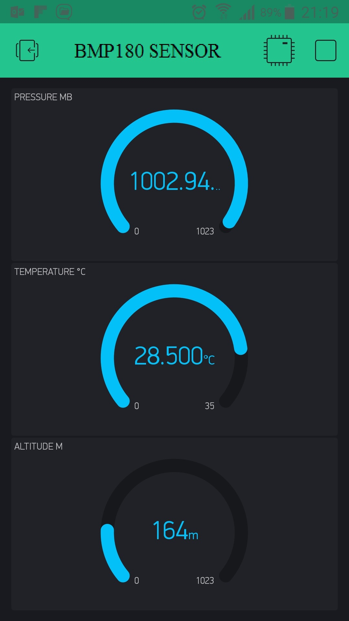
Figure 10. Monitoring of pressure, temperature and altitude through time via Blynk

Moreover for the mentioned weather station project the expansion of implementation is envisaged. In the further development phases on the existing project model can be added new sensors to measure other essential meteorological parameters. Whenever some parameter values exceed chosen threshold limit then SMS, e-mail, or tweet can be generated to take necessary further actions. In addition from the obtained measure values it can be calculated dew point, rain value, light intensity, UV radiation in the air area. The proposed IoT based weather station can be modified to incorporate more functional tasks, in connection with the web server environment and associated end-user services. [10]

5. CONSLUSION

Today the IoT systems are gaining more and more applications in different technological fields. Data collection, integration and analysis are very complex and demanding but cost effective. The IoT approach also can find a functional application in project teaching by multidisciplinary lesson units.
The operational meteorological stations are widespread and used. The large ones are found in institutes, companies and services where current weather data are of priceless importance. However, it is possible to make, from ready-made elements, available sensors, innovative software applications, cell models that are not complex, but highly accurate and quite cheap.
In connection with contemporary circumstances the IoT based projects are also inventive resources that must be seriously considered for relevant present and future training and learning activities. Theory and practice of researches processes, helped by technologies, must be interconnected as much as possible. New, innovative and content projects are extremely valuable for the education of students and others in total. This is especially true for the technical vocational subject contents and courses individually, or even with the multidisciplinary method of implementation.
This paper gives a short review of the elements and functions for the IoT meteorological station model. The listed can be aimed to the project teaching as well. That model can be applied in several technical vocational subjects in schools, but also may have prominent commercial use. In this report creation process of the efficient weather station model has described in detail. The model consists of ESP32 microcontroller, DHT22 sensor, BMP180 sensor, MQ135 gas sensor and accompanying equipment. The collected data and analysis results will be available to the end users through the classical Wi-Fi network and internet link. The listed system is an advanced solution for weather monitoring that uses the IoT platform to make real time data easily and almost without costs accessible over a wide parameter range. For the project demand special code for a Blynk Application was developed, tested and then implemented in existing weather conditions.
The performances of a unique Blynk application for the hardware and software connections of various devices are extraordinary. The collected data from different sources may be storage, exchange and then optionally analyze, all of that with minimal resources and financial costs. The significance of studying this program and project approaches are multiple, specially for certain courses in the frame of practical implementations. At the same time, just with this methodology the topics of several scientific fields are mutually intertwined. Students acquire simultaneously appropriate knowledge and relevant skills about sensors, microcontrollers, automation, programming. They can examine and test the specified systems and theirs equipments as well. In the current circumstances the engineering imperative certainly remains optimization, ie. further improvement of existing and development of better meteorological station solutions for the timely, precise and functional weather forecasts.

REFERENCES
[1] Đorđević M., Danković D. A Smart Weather Station Based on Sensor Technology, Facta Universitatis, Vol. 32, No2, pp. 195-210, 2019.
[2] Krasnikova K. S., Kopaniev V., Vasylenko M. Smart Leakage Monitoring System with Blynk IoT Integration Using Arduino, Electronics and Control Systems 1(59), DOI: 10.18372/1990-5548.59.13639, 2019.
[3] How Blynk Works. retrieved June 18, 2020. available on https://docs.blynk.cc.
[4] Getting started with Blynk simple DIY IoT devices. retrieved July 9, 2020. available on https://hr.unedose.fr/article/getting-started-with-blynk-simple-diy-iot-devices.
[5] New Blynk IoT Platform Version. retrieved July 27, 2020. available on https://blynk.io/blog/new-blynk-platform-web-dashboard-over-the-air-updates-and-machine-learning.
[6] DHT22, retrieved July 26, 2020 available on https://cityos-air.readme.io/docs/4-dht22-digital-temperature-humidity-sensor.
[7] BMP180 Digital Pressure Sensor. retrieved August 3 2021. available on https://www.mouser.fr/datasheet/2/783/BST-BMP180-DS000-1509579.pdf.
[8] MQ135 Gas Sensor for Air Quality, retrieved August 7 2021. available on https://components101.com/sensors/mq135-gas-sensor-for-air-quality.
[9] ESP 32, retrieved July 19 2020, available on https://www.espressif.com/en/products/socs/esp32.
[10] Kodali R. K., Mandal S. IoT based Weather Station, International Conference on Control, Instrumentation, Communication and Computational Technologies, 2016.

