ANALYSIS OF DIFFERENT EXTRAPOLATION METHODS APPLIED IN LOW-POWER SYSTEMS WITH APPLIED VRS ALGORITHM

dr Bojan Prlinčević¹; dr Zoran Milivojević²;
¹ Kosovo and Metohija Academy of Applied Studies, Leposavić, SERBIA, bojan.prlincevic@akademijakm.edu.rs
² The Academy ofApplied Technical and Preschool Studies, Niš, SERBIA, zoran.milivojevic@akademijanis.edu.rs

Apstrakt: In the first part of this paper a Variable rate sampling, algorithm for prediction at systems with reduced power demand has been described. In the second part is performed an experiment where is tested algorithm for prediction of transmitted temperatures values. Prediction on the transmission side is performed using mam, mab, and ng extrapolations. At the received side reconstruction of the received signal is performed applying Linear, Cubic, Makima, and Spline extrapolations, built into Matlab. A simple reconstruction is also performed, which was used the last known value for the next value, for this purpose named Step extrapolation. Objective quality measures SR (correlation coefficient of reducing the number of samples between a number of measured and transmitted samples), and MAE (mean absolute error between the measured and predicted values of temperatures) were calculated. The results are presented in the table and graphically.

Ključne reči: Low Power consumption, VRS algorithm, Extrapolations

1. INTRODUCTION

Wireless sensor networks (VSN) are very common in modern communications. During operation, they most often use chips of low power [1] and small dimensions. Chips most often use energy from battery power for their functioning. Due to limited power supply, it is necessary to ensure that the batteries have a long service life. The long life of a battery power source can be provided in two ways. The first way is to install high-power batteries, which limit is the size of the power source itself. Another way is to manage consumption. Consumption management can be achieved by applying a system with reduced consumption (Low-power consumption, LPC). LPC systems are applied in all spheres of society (consumer devices, military industry, medical devices, etc.). A characteristic example of the application of LPC system is measurement (pressure, temperature, river levels, etc.) where there is no constant and stable power source. In these systems, the connection of sensor to the central computer is usually through the radio connection. In order to save energy, i.e. reduce consumption, systems with dynamic consumption management (DPM) are used [2]. DPM is used to control the power supply by voltage variation [2-4] or processor clock speed control [1], [5], [6].
In digital processing systems, the sample rate of an analog signal is determined in relation to the maximum frequency of the analog signal. In most cases, the sampling rate is not variable over time, and therefore the application of the LPC system can reduce the sampling rate in order to reduce energy consumption. LPC systems can be also applied to VSN model if the intervention aimed at energy saving is conducted during the process of sending or receiving signal. This approach would ensure that there are no deviations in a quality of measured and transmitted information. The reduction of frequency of sending signal is realized in time intervals whereas small changes or constant amplitude can be observed on the analyzed signal. The selection the transmitting interval is very important because frequencies of sending samples directly affects the system performance and energy consumption. The sampling rate and sending samples rate can cause losses important information[7]. Errors that occur can significantly affect the decisions made on such information.
Error reduction is accomplished by applying algorithms with Variable-rate sample - VRS [8]. The algorithm described in [8] changes the sampling time depending on the change rate of sampled signal parameters. The sampled signal parameters are compared with a threshold that is defined based on the type of the signal. In [9], [10], the VRS algorithm with prediction is presented.
In this paper, the VRS algorithm presented in [9], [10] is analyzed. The algorithm was applied to the signal that was created for the temperature values measured on measuring station "Sunčani vrhovi" at Kopaonik mountain, for the period from 01.09. to 30.09.2020. [11]. The application of the VRS algorithm was performed by sending a signal depending on the defined temperature threshold. In addition, the VRS algorithm is set up in a way that after a certain time interval with no changes of parameters (temperature), it sends test signal to demonstrate that the system operates. Maximum sleeping time, where system do not send a signal, is defined as one of the parameters of the system.
On the transmitting side, for the purpose of detailed analysis, signal sampling with different sampling steps was performed. The signal transmission prediction was performed by extrapolations shown in [9]. The transmission signal is reconstructed on the received side. For the purpose of analysis, on the receiving side, signal reconstruction was performed using the functions for Linear, Cubic, Makima, and Spline extrapolations, built into Matlab. A simple reconstruction is also performed, that was used the last known value for the next value. This extrapolation for the purposes of this paper is called Step extrapolation.
The gain, that is, energy saving was determined by a coefficient that represents the ratio of the number of measured samples and the number of transmitted samples with the implemented VRS algorithm. The precision of prediction of used extrapolations methods was measured using MAE, which represents error between measured and predicted values for each extrapolation method.
The paper is organized as follow: Section 2 describes the VRS algorithm. In section 3, an experiment was performed, and the results and analysis of the results were presented. The conclusion is given in section 4.

2. ALGORITHMS

In [9], [10], a VRS algorithm was implemented in the systems for collection and transmission of data, which are battery powered. The connection between the VRS controller and the computer for data processing and archiving (base station) was realized by radio connection. The change of performance of a signal sent from the sensor is as such that the maximum change of the amplitude, the sampled signal of the temperature, varied in the range from T_{min} to T_{max}, and the change of sampling time was varied in the range from t_{min} to t_{max}.
Measured values x(t) is converted, in sensor, into electrical signal y(t). The sampling of the signal is conducted in the time interval t_{n}, where n=0,1,2, ..., and generates the signal y_{n}. After the sampled values yn in the time t_{n} prediction was performed. At the time t_{n+1} the sampling of the signal y_{n+1} is performed, which presents the real value of the signal. Prediction error depends on sampling time h in f(t,y). The prediction value can be defined as:

, (1)

where f(t,y) is predicted value between known values (t_{n}, y_{n}) and (t_{n+1}, y_{n+1}).
Different numerical methods for calculating f(t,y) have been developed, which can be generally classified in two groups:
a) single step method (Euler method, Runge-Kutta method, ...); and
b) multistep method (Adams-Bashforth method, Adams-Moulton method, ...).
The prediction formula, based on the Adams-Bashforth formula of the fourth order (AB4), is [6]:

. (2)

The following three formulas are used for reconstructions of received signals. Adams-type formula, which contains only y values, is [9]:

, (3)

where is a prediction using the modified combined Adams method.
The prediction formula based on the combined Adams-Bashforth-Moulton method is:

. (4)

The prediction method, fourth-order N–G, backward differencing polynomial is [9]:

, (5)

where is the result of extrapolating the N–G interpolation polynomial.

2.1. VRS algorithm

The VRS algorithm [9] implementation is based on that, we either halve or double the step size, depending on whether the most recent sample was outside or inside a given tolerance compared with the predictions described in (3), (4) and (5). That is, is doubled if the prediction is sufficiently accurate and halved if the prediction is inaccurate:
1) Step Size Doubling: The system requires that nine successive equispaced data values are stored in a first-in-first-out (fifo) structure. A calculation for is performed using (3). At the next sample time, y_{n+1} becomes y_{n} and so on, and the previous value of y_{n-8} is discarded from the fifo. If the new value for y_{n} is within tol/2 for the predicted value, the sample step h is doubled. Once the process of doubling h is complete, only four more samples must be taken before can be doubled again. However, can be halved on the next sample if required because only five readings are required.
2) Step Size Halving: To halve , the interpolated values of y_{n-1/2}, y_{n-3/2}, y_{n-5/2}, and y_{n-7/2} must be calculated to refill the fifo with values at the new sample rate. Again, this can be achieved using the N–G fourth-order backward differencing polynomial in (5).
The VRS algorithm is implementated in the sytem as follows [9]:
/* tol tolerance */
/* h_{max} maximum sampling step */
/* h_{min} minimum sampling step */
Set tol
Set h_{max}
Set h_{min}
Set h=h_{min}
Read the first nine values y_{n-8},...,y_{n}
Until data
Calculate
Read
Set y_{n-8}=y_{n-7},...,y_{n}=y_{n+1}
If then
If h>h_{min} then halve h
else if then
If h<h_{min} then
If duplicating the last four values
then duplicating h
else do not change h
Loop

3. EXPERIMENTAL RESULTS AND ANALIZE

3.1. Experiment

In order to test the VRS algorithm application in the systems with reduced energy consumption, the base of temperature values was created. The Base is created for September for the mountain Kopaonik where the values are taken from the measuring station "Sunčani vrhovi". The measured temperature values are for a time interval of 1h. Table 1 shows the temperatures for the second week of September. Figure 1 shows scale of all measured temperatures for September 2020. For the requirements of the experiment, the signal was varied in a way where the change of temperature sampling was performed in the range from T_{min} = 0.01ºC to T_{max} = 2ºC, and the change of sampling time was varied in the range from t_{min} = 1h to t_{max} = 4h.

Table 1: Base of Temperatures (ºC)
 | Temperature ºC
Time (h) | Date  08.09.2020. | Date  09.09.2020. | Date  10.09.2020. | Date  11.09.2020. | Date  12.09.2020. | Date  13.09.2020. | Date  14.09.2020.
0 | 12.8° | 9.2° | 12.2° | 10.9° | 10.3° | 11.1° | 11.7°
1 | 12.0° | 8.8° | 11.0° | 9.7° | 11.3° | 11.1° | 11.9°
2 | 11.7° | 8.9° | 10.6° | 8.9° | 11.1° | 11.1° | 11.7°
3 | 11.3° | 9.0° | 10.4° | 8.8° | 11.2° | 9.6° | 12.5°
4 | 11.3° | 8.8° | 9.7° | 10.4° | 11.5° | 9.8° | 12.3°
5 | 11.1° | 10.6° | 9.4° | 10.0° | 11.1° | 10.0° | 12.2°
6 | 11.7° | 10.5° | 9.3° | 10.2° | 10.7° | 8.7° | 11.6°
7 | 11.5° | 10.7° | 9.9° | 10.5° | 11.2° | 9.8° | 12.1°
8 | 11.7° | 12.8° | 14.4° | 12.2° | 13.3° | 12.8° | 13.3°
9 | 12.4° | 13.3° | 15.8° | 13.2° | 14.3° | 14.7° | 15.1°
10 | 14.8° | 14.5° | 17.4° | 14.5° | 14.8° | 15.3° | 15.7°
11 | 13.9° | 15.0° | 17.2° | 15.6° | 15.6° | 15.6° | 16.1°
12 | 13.0° | 16.0° | 16.4° | 15.9° | 15.9° | 16.2° | 17.3°
13 | 14.4° | 16.2° | 17.2° | 16.9° | 16.7° | 16.7° | 15.7°
14 | 14.4° | 17.2° | 16.7° | 16.1° | 17.2° | 16.7° | 17.2°
15 | 13.7° | 17.9° | 16.1° | 16.1° | 17.2° | 16.6° | 17.1°
16 | 13.9° | 18.4° | 17.4° | 15.6° | 16.8° | 16.1° | 16.4°
17 | 13.9° | 18.4° | 17.4° | 15.6° | 16.8° | 16.1° | 16.4°
18 | 13.5° | 17.4° | 15.4° | 15.1° | 15.3° | 15.5° | 14.9°
19 | 12.7° | 14.2° | 12.7° | 13.8° | 13.5° | 13.6° | 14.1°
20 | 12.2° | 12.2° | 11.1° | 12.8° | 13.3° | 13.3° | 13.3°
21 | 11.0° | 11.1° | 12.0° | 12.3° | 12.7° | 12.6° | 13.1°
22 | 10.0° | 10.6° | 11.4° | 12.0° | 12.7° | 12.1° | 12.5°
23 | 9.4° | 12.2° | 11.7° | 11.1° | 12.8° | 11.7° | 12.8°

The minimum sampling time of temperature sending signal is t_{min} = 1 (h). This time is in line with intervals of temperature measurement at the sampling site. Maximum sampling time is limited at t_{max} = 4 (h) The measured temperatures had values rounded to one decimal place so that the tolerance values of sending samples were from 0.1 ºC to 2 ºC. The principle of operation of the VRS algorithm is shown in Figure 2.
On the receiving side, the extrapolation methods: Linear, Cubic, Makima, and Spline were applied in order to reconstruct the received signal. The built-in functions in MATLAB were used to apply these methods. Also, for the purpose of this experiment is introduced extrapolation, from the authors named, Step. The Step extrapolation used the previously known value to predict the next value. In the step extrapolation, the Previous value became the predicted value.
The effect of the VRS algorithm is observed on the reduced number of sent samples during the defined sending interval, and all in accordance to the parameters of the signal y(t). The Sample Ratio (SR) is introduced as a measure of reduced the number of data sent to the recipient:

(5)

where N_{s} is number of samples at a constant sampling step, N_{s_vrs} number of samples at application the VRS algorithm.
As an objective quality measure between measured value of the signal (temperature) and reconstructed value of the signal, the mean absolute error – MAE was used:

(6)

where N is the number of samples in the defined time interval.

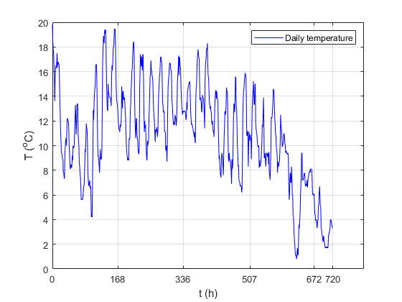  Figure 1. Base of daily temperatures for month September, hourly (720 h). | 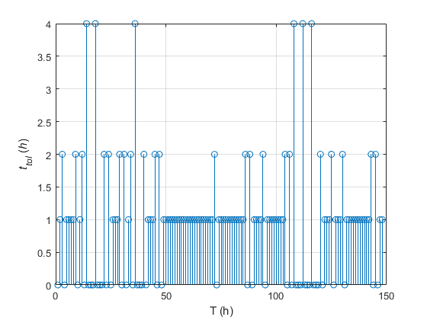  Figure 2. Principle of functioning the VRS algorithm, presented for temperatures in second week in September.

3.2. Results

The result of the effect of applying the VRS algorithm for temperature varying are presented in Figure 3 Tolerance of the temperature values was varied in the range from 0 to 2ºC with the step of 0.1ºC. Table 1 Figure 4 shows a comparative diagram of MAE for different sampling time for: a) Linear, b) Cubic, c) Makima, d) Spline, and e) Step extrapolations. Figure 5 shows a comparative diagram of MAE for used extrapolations for different sampling time: a) t = 1 (min), b) t = 5 (min), a) t = 15 (min), d) t = 30 (min), and a) t = 60 (min). Table 1 shows mean MAE for used extrapolations for different value of tol. Figure 5 shows mean MAE for used extrapolations for different value of tol.

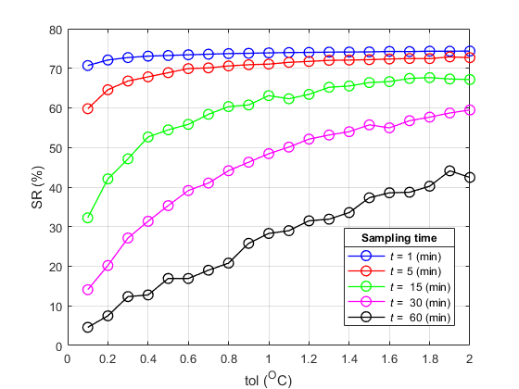
Figure 3. Sample ratio measure for applied VRS algorithm for different time of sampling.

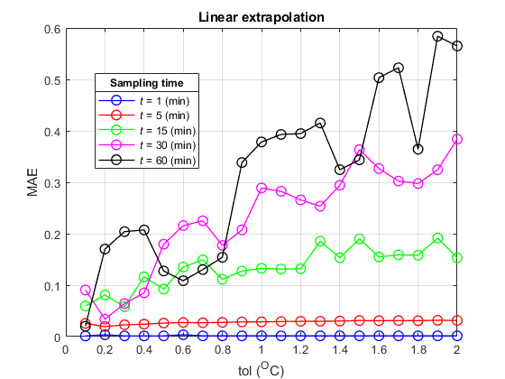
a)
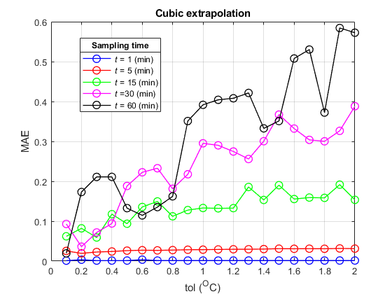  b) | 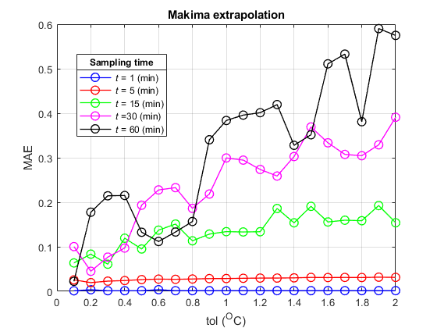  c)
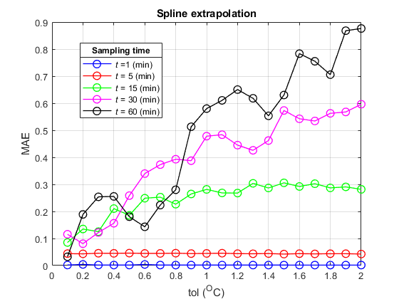  d) | 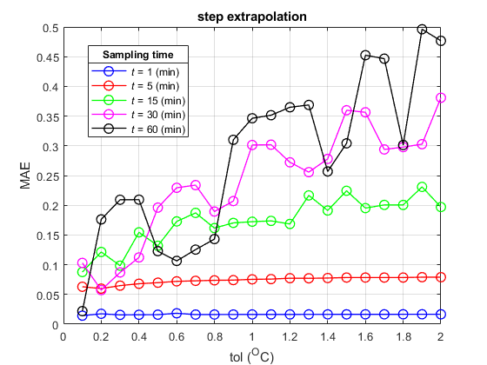  e)
Figure 4. MAE for: a) Linear, b) Cubic, c) Makima, d) Spline, and e)Step extrapolations.

Tabela 1: Average MAE for different tol
 |  | Extrapolation
Sampling time | t | Linear | Cubic | Makima | Spline | Step
Sampling time | 1 | 0.0016 | 0.0016 | 0.0016 | 0.0020 | 0.0164
Sampling time | 5 | 0.0282 | 0.0281 | 0.0282 | 0.0443 | 0.0736
Sampling time | 15 | 0.1336 | 0.1343 | 0.1353 | 0.2452 | 0.1729
Sampling time | 30 | 0.2331 | 0.2386 | 0.2421 | 0.3949 | 0.2408
Sampling time | 60 | 0.3125 | 0.3193 | 0.3187 | 0.4851 | 0.2795

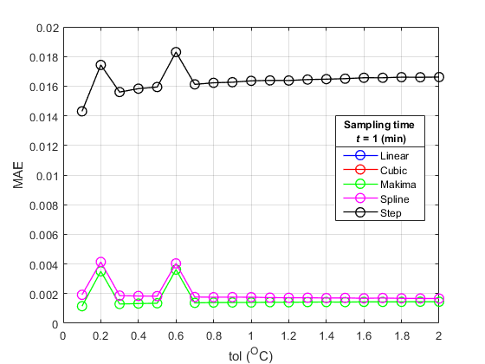
a)
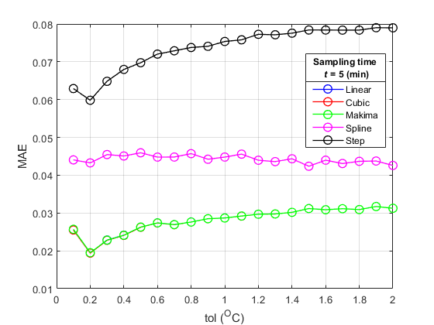  b) | 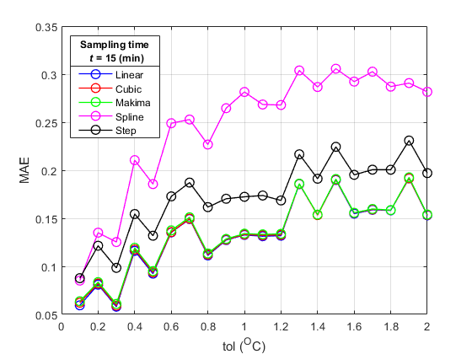  c)
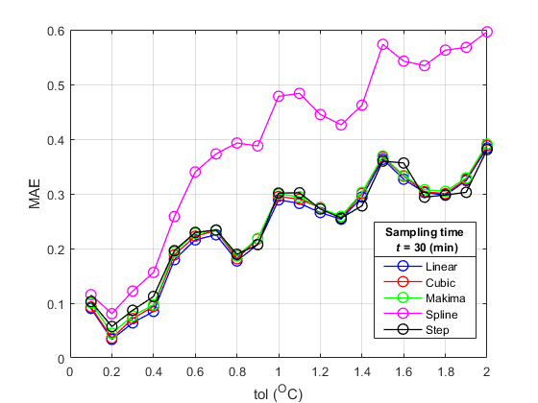  d) | 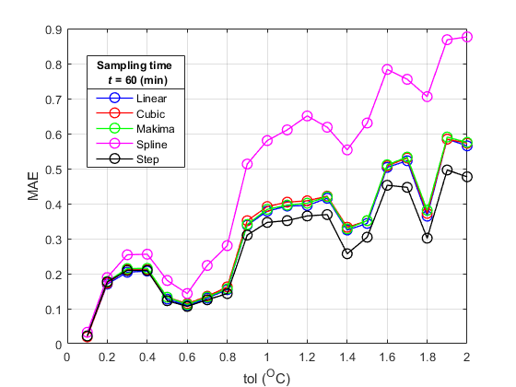  e)
Figure 5. MAE for Linear, Cubic, Makima, Spline, and Step extrapolations for different sampling time: a) t = 1 (min), b) t = 5 (min), a) t = 15 (min), d) t = 30 (min), and e) t = 60 (min).

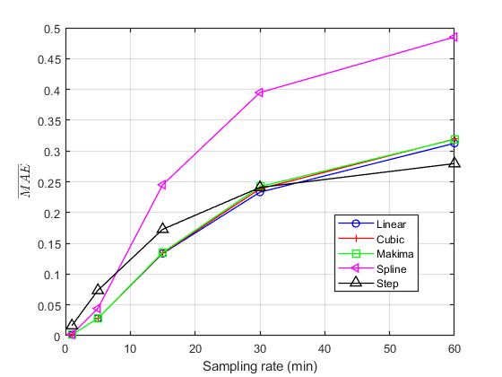
Figure 6. Aaverage MAE for different tol.

3.3. Analysis of results

Based on the results shown in Diagram presented on Figure 3, it can be concluded that with the increase of the sample rate temperature tolerance, the positive effect of the application of the VRS algorithm increases. The higher value of SR indicates the lower energy consumption for signal transmission, that is, the smaller number of samples was sent. Also, on this Diagram we can see that if sampling time is smaller (t = 1 min) there is the high value of SR regardless of the sampling temperature value, tol. On the other side, for sampling time (t = 60 min) SR rapidly increases regarding increasing sampling temperature value, tol.
Analyzing the values for MAE, presented on the diagram shown in Figure 4.a, 4.b, and 4.c, it can be concluded that the Liner, Cubic, and Makima extrapolations give similar (with closely values) results, for all varied sampling conditions (both for varied time and temperature). From the diagram shown in Figure 4.d it can be concluded that the Spline extrapolation compared to Liner, Cubic, and Makima extrapolations gives worse results. From the diagram shown in Figure 4.e it can be concluded that the Step extrapolation compared to other extrapolations gives the best results.
Analyzing the values for MAE, presented on the diagram shown in Figure 5 it can be concluded that the Step extrapolation gives worse results for sampling time t = 1(min) and t = 5 (min) comparing to other extrapolations. For sampling time t ≥ 15 (min) Spline extrapolation gives worse results and Step extrapolation gives better results (make a smaller error).
Analyzing results, shown in Table 1 and Figure 6, which presents values for averaged MAE, it can be concluded that for sampling time t ≤ 30 (min) Linear, Cubic, and Makima extrapolations gives better results (smaller average MAE) compared to Spline and Step extrapolations. For sampling time t ≥ 30 (min) Step extrapolation become with best results gives smaller average MAE) compared with other. Spline extrapolation for sampling time t ≥ 30 (min) gives worse results (higher average MAE).

4. CONCLUSION

Using the experiment, the paper analyzes efficiency of VRS algorithm for transmission of temperature values from measurement station "Sunčani Vrhovi" on the mountain Kopaonik for September. The efficiency of the VRS algorithm is performed as a function of the precision of predictions of the results on the transmitted side. For predictions are used Linear, Cubic, Makima, Spline, and Step extrapolations. Using the experiment, the results of objective quality measures of VRS algorithm and precisions of extrapolation functions (SR, MAE) are obtained. Based on the values of objective measures SR, it can be concluded that application of the VRS algorithm for the reduction of energy consumption through the reduction of the number of sending samples, gives positive result. Based on the values of objective measures MAE, it can be concluded that application of the Step extrapolation function gives better result for prediction if sampling time is higher. If sampling time is smaller then t ≤ 30 (min), Liner, Cubic , and Makima extrapolations gives better results in predictions. Based on presented results, it can be concluded that VRS algorithm, in which the reconstruction of the signal on the receiving side is based on the Liner, Cubic, Makima, Spline, and Step extrapolation for prediction, can be used for application in real - time operation systems, but with different extrapolation method depending of application system.

REFERENCES

- C. Zhuo,Sh. Luo, H. Gan, J. Hu and Zh. Shi, "Noise-Avare DVFS for Efficient Transitions on Battery-Powere IoT Devices", IEEE Transactions on Computer-Aided Design of Integrated Circuits and Systems, Vol. 39, Issue 7, July 2020.
- L. Benini, A. Bogliolo, G. Micheli, "A survey of design techniques for system-level dynamic power manage-ment", IEEE Trans. VLSI Syst., Vol. 8, pp. 299-316, June 2000.
- P. Wu, et. al., "PVT-aware digital controlled voltage regulator design for ultra-low-power (ULP) DVFS systems", Proc. SoCC, pp. 136-139, 2014.
- M.B. Srivastava, A.P. Chandrakasan, R.W. Brodersen, "Predictive system shutdown and other architectural techniques for energy efficient programmabble computa-tion", IEEE Trans. VLSI Syst., Vol. 4, pp. 42-55, Mar. 1996.
- L. Benini, A. Bogliolo, G. Micheli, "A survey of design techniques for system-level dynamic power manage-ment", IEEE Trans. VLSI Syst., Vol. 8, pp. 299-316, June 2000.
- N. Rizvandi, et. al., "Multiple frequency selection in DVFS-enabled processors to minimize energy consumption", John Wiley & Sons, 2012.
- A. Banerje, A.S. Dhar, S. Banerje, "FPGA realization of a CORDIC based FFT processor for biomedical signal processing", Microprocessor Microsyst., Vol. 25, no. 3, pp. 131-142, May 2001.
- J.W. Mark, T.D. Todd, "A nonuniform sampling approach to data compression", IEEE Trans. Commun. Vol. COM-29, pp. 24-32, Jan. 1981.
- G.B. Irvine, L. Wang, P. Dickman, D. Cumming, "Varia-ble-rate data sampling for low-power microsystems using modified Adams method", IEEE Trans. on Signal Pro-cessing, Vol. 51, no. 12, pp. 3182-3190, Dec. 2003.
- S. Milivojević, Z. Milivojević, "Analysis of the VRS prediction algorith at a low-power system", Poceeding of VTŠ Niš, dec 2006.
- Istorijski Meteorološki podaci Kopaonik(Suncani Vrhovi) - Synop | Weather2Umbrella LTD.

