DEFINING THE QUALITY OF THE BASE MATERIAL DUE REPAIR WELDING

Drakce Tanaskovic¹, PhD; Slobodan Petrović², Mag; Branislav Đorđević, PhD³
¹ HBIS GROUP Serbia Iron & Steel, Smederevo, Serbia, drakcetanaskovic@gmai.com ,
² College of Applied Sciences, Uzice, Serbia, slobodan.petrovic@vpts.edu.rs
³ Innovation centre of Faculty of Mechanical Engineering in Belgrade d.o.o., Serbia, brdjordjevic@mas.bg.ac.rs

Abstract: In this paper is shown the comparison of different methodologies for defining the quality of base material due repair welding as one of the basic and initial problems during repairing of damaged parts or machine equipment. The problem of defining the quality of base material is reflected in the impossibility of undertaking the next step of the procedure during repair of the damaged part, development of welding technology etc. The quality of repaired previously damaged machine part depends on the successfully defined quality of the base material. In addition to the analysis of discussed methodologies, the paper also provides a diagram of the decision flow between different methodologies. The overall analysis was performed in the company HBIS GROUP Serbia Iron & Steel, Smederevo.

Keywords: base material quality, repair welding, steel, quality

1. INTRODUCTION

During all these years, repair welding remained an insufficiently defined scientific and technological field, despite the exceptional technical improvements in welding, as well as new materials research. Unlike the production welding, repair welding is usually more complex due to several unknown elements and factors that follow repair welding process.
Most metallic materials have a good weldability or can be welded under certain condition [1, 2]. After failure of machine/construction parts repair welding can took place instead of replacing damaged part with new one. However, preserving the characteristics of the material after repair welding can be very difficult to achieve or may require good designed technology process. In order to perform a good repair welding technology on damaged part, it is simply necessary to know the composition of the base material as well as all its characteristics (mechanical, physical etc.) This is also necessary in order to prepare and determine a successful repair welding procedure. The designation as well as characteristics of base material can be given by machine manufacturer, or material manufacturer, on technical documentations etc. If necessary, the chemical composition of the base material could be analyzed, even if designation of material is known. This could be caused by exploitation condition as well, i.e. condition that can change chemical structure and composition of material. But sometimes the base material of damaged part could be just unknown which could be caused by several reasons. One of them is just a fact that damaged equipment (that could be easily repaired, e.g.) is very old, causing the loss of required documentations [3]. Unknown characteristics of base material could lead to establishing bad repair welding procedure, which could lead again to – failure.
In this paper are discussed few different methodologies for defining the quality of base material due repairing by welding, which could be one of the basic and initial problems during this process. The problem of defining the quality of base material is reflected in the impossibility of undertaking the next step procedure during repair of the damaged part, development of welding technology etc. A proposed algorithm represents original approach and provides the steps on “decision flow” during repair. This algorithm is designed in order to help engineers in decision making due establishing and creating appropriate repair welding procedure.

2. PROPOSED ALGORITHM

Defining the quality of the base material represents one of the major problems due the repair welding of damaged parts or constructions. In practice, several cases can be distinguished. According to aforementioned, the way to define the quality of the base material of damaged part which needs to be repaired can be presented with algorithm in Fig. 1. The first question defines two basic ways (branches) on further algorithm steps – are there any drawing or technical documentation? In further chapters of this paper are given detailed explanations of this algorithm, leading it to final steps – established repair welding technology.
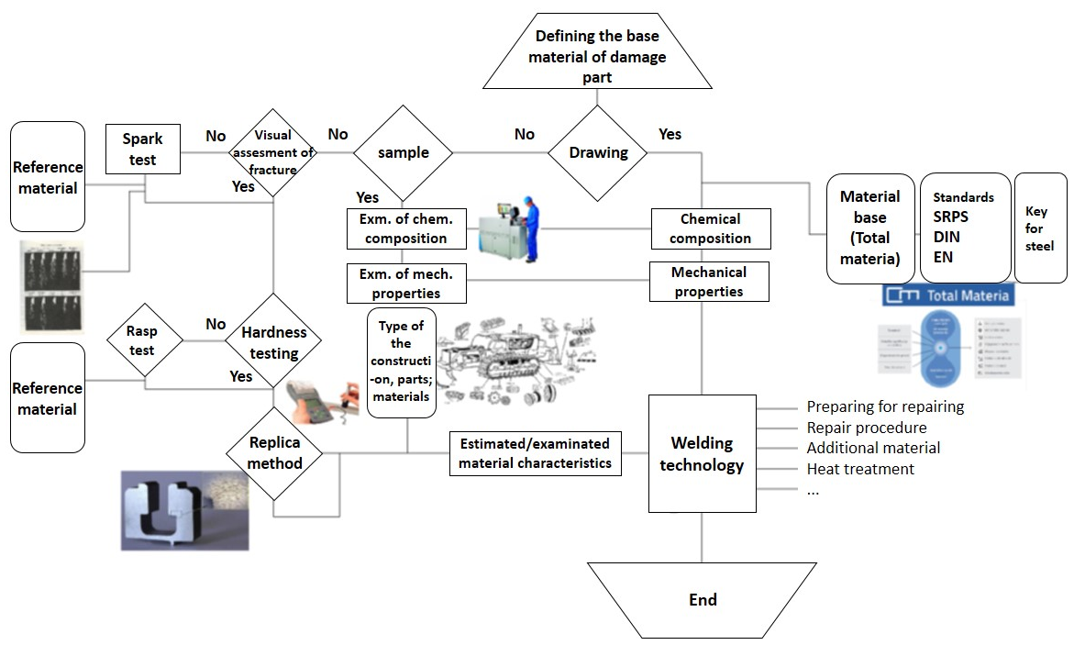
Figure 1: Algorithm and steps of defining the quality of base material

2.1 Defining the quality of base material based on technical documentation
As can be seen from the algorithm in Fig. 1, the simplest case represents the one with complete technical documentation or drawings of the part/construction. Based on the material designation (according to relevant standards, e.g.), chemical composition and mechanical properties of the base material can be obtained from these documentation, which represent good ground for defining the welding procedure, additional (filler) material, adequate heat treatments, i.e. data sufficient for development of repair welding technology [4-7].
One of the most complete databases of steel materials is Total Materia database [8], which provides:
- the largest data source in the world, database with material properties with more than 12 000 000 records, for more than 450 000 materials.
- the most powerful system of comparison tables; the fastest and most comprehensive system of international comparison tables, with a unique categorization of equivalents and with the additional application of SmartCross technology, which represents a patented algorithm based on artificial intelligence.
- advanced calculation properties; the largest collection of data on stress-strain, fatigue, and plasticity curves. Besides that, it supports linear and nonlinear calculations and opens up new possibilities during construction designing.
- unique material identification; based on the patented chemical composition-based metal identification algorithms recognized by leading spectrometer manufacturers around the world, which allow the identification of unknown materials per second.
- certified quality, reliable and always updated data; high quality and maximum reliability, unique multiple certified quality of process and information security in industry, with a unique update policy, including the possibility of uploading of data for each material.
All aforementioned is illustrated in Fig. 2.
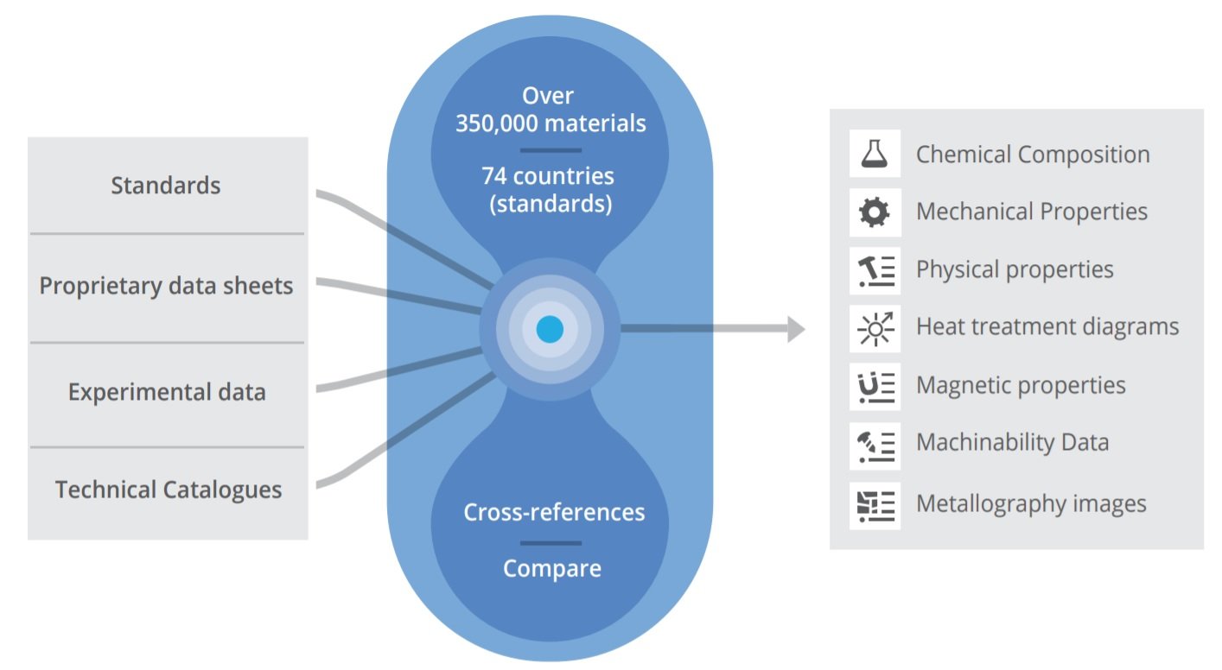

Figure 2: Total Materia database
2.2 Defining the quality of base material based on examination of chemical composition
In most cases, there is no documentation or any data on the quality of damaged part material. In these cases, if it is possible, a sample needs to be taken from the damaged part (a small plate with a minimum diameter of 40 mm and a thickness of 5 mm) with order to perform the chemical composition examination. Examination of the chemical composition needs to be performed on adequate equipment, such as spectrometer (Fig.3).
Quantometers or spectrometers are automatic spectral devices with photoelectric spectrum registration which provide direct measurements and readings from them. While the photographic registration of the spectrum requires a special procedure for measuring and evaluating the blackening of the emulsion, the quantometer directly determines the intensities of the spectral lines [1]. The advantages of such measurement are:
- fast analysis
- high accuracy
- higher precision at higher contents
- linear dependence between concentrations and intensities in a wide range of concentrations
- possibility of comparing distant spectral lines
- possibility of automation.

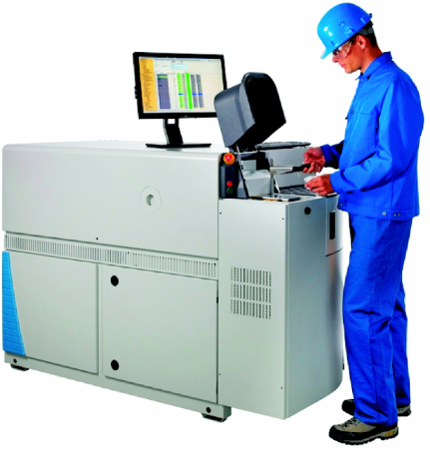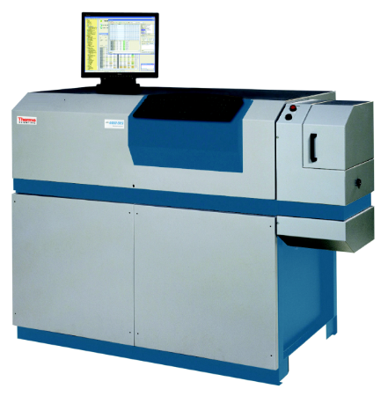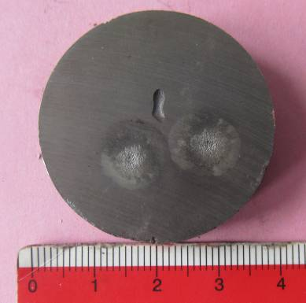
a) b) c)
Figure 3: a) iSpark Series Optical-Emission Spectrometer; b) ARL 4460 Optical-Emission Spectrometer;
c) Procedure of examination of chemical composition of sample

Optical emission spectrometers (such as ARL 4460 and 3460) are used for simultaneous examination of concentrations of chemical elements in samples with Fe base (iron and steel) [9, 10]. Quantometers or spectrometers with direct reading are automatic spectral devices with photoelectric registration of spectrum. While the photographic registration of the spectrum requires special procedure for measuring as well as evaluating the blackening of the emulsion, with quantometer intensities of the spectral lines can be directly determined. Such devices are very expensive and in possession of large companies and institutes.
Testing of mechanical properties requires taking samples of larger dimensions and longer testing period (which includes test samples making). Taking larger samples further affects the geometry of already damaged or broken part or construction.

2.3 Defining the quality of base material based on visual inspection
Based on the visual inspection and appearance, using methods such as color identifying, or magnet, it is possible to determine and evalute a group of the material from which it is made (i.e. steel, stainless steel, cast iron, cast iron, copper, bronze, brass, aluminum etc). It is known that all metals are gray, except copper, which is red, and gold, which is yellow.

2.4 Defining the quality of base material with spark testing
By grinding the machine part surface and comparing it with reference materials, it can be confirmed precisely to which group of damaged part material belongs. Experienced technician and engineer can determine it with great certainty. Spark testing is used because it represent quick, easy, and inexpensive way of testing and determining the chemical composition. Test samples do not require any preparation, thus a piece of scrap can often be used for testing. The main disadvantage to spark testing is its inability to identify a material positively. The spark comparison method also damages the material being tested.
Figure 4 shows some examples of the spark testing of the different steels. In the Fig. 4a and b are given spark testings of X12NiCrSi35-16 and 42CrMo4 steels, respectively,
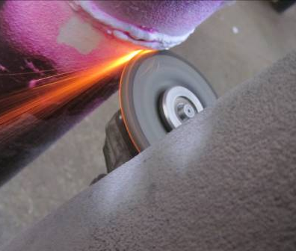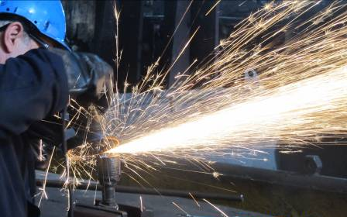
- b)
Figure 4: a) Burner pipe spark testing (base material X12NiCrSi35-16); b) Spark testing of 42CrMo4 steel
2.5 Defining the quality of base material with hardness testing
Most often, even if the base material is known, it is necessary to have additional information about material in order to determine adequate welding technology of it, additional material, heat treatment etc. By measuring the hardness of the material, obtained data need to be compared with the hardness values of reference materials (or steels). The hardness values above 350 HV for non-alloy and 450 HV for low-alloy steels show high hardenability of steels as well as low weldability [11, 12]. Based on the measured hardness value the strength of the material can be approximately determined, as well as material denotation itself. Due hardness measuring, care should be taken of surface coatings caused by heat treatments, such as cemented, nitrided, chromed one etc. Devices used for hardness testing have broad application nowadays, epically in repair welding [3, 13]. Display of the hardness testing example is given in Fig. 5. The hardness of the material can be measured with a rasp as well.
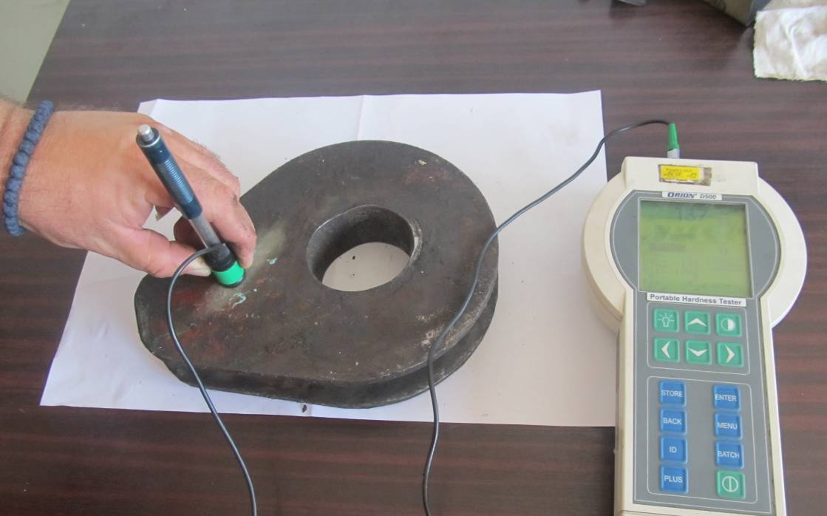
Figure 5: Hardness testing
2.6 Defining the quality of base material by replica method
This method represents a non-destructive method based on the analysis of damaged structure is possible to determine the causes of construction failure [13, 14].
The imprint of the part micro-structure has to be performed using appropriate equipment. Before testing itself, it is necessary to prepare the surface. The necessary steps during testing includes a grinding, polishing procedure, etching the tested surface with reagents, while control of these steps can be performed using a small optical microscope. The next operation is taking imprint from prepared surface with replica coated with a softener, by applying the replica on the prepared surface. After a certain time, the dried replica has to be placed between two glass plates (operation of replica method is given in Fig. 6).
The imprint on the taken replica can be observed on optical microscope, either on a mobile one or in a laboratory.
Based on the analysis of the tested surface imprints, with replica method testing it is possible to perform the following assessments:
- the remaining life of the material in service
- types of defects on the material and the cause of their occurrence
- the cause for the construction/machine failure
- monitoring of micropores and cracks occurrence
- structural changes on welded joints
- corrosion damage of the metal surface.
Also, this method is often used in combination with other non-destructive testing methods such as magnetoflux, penetrant, ultrasound methods of testing [15], or hardness testing [16].

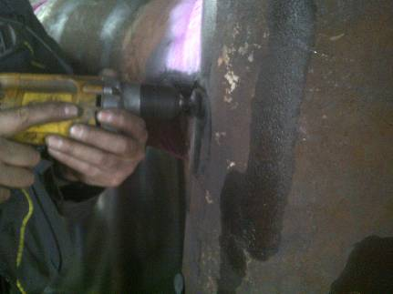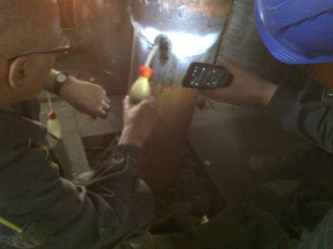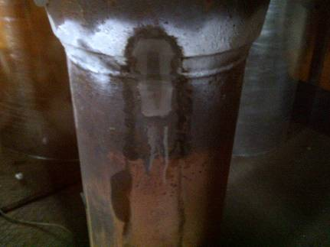
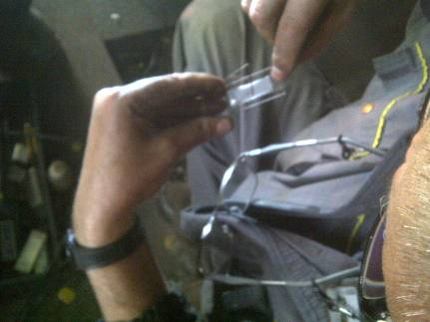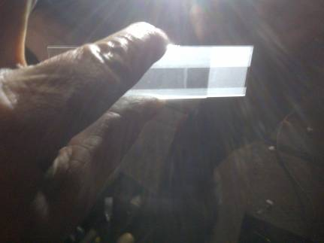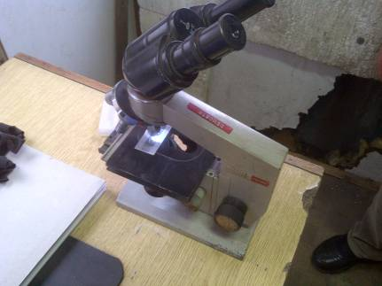
Figure 6: Replica method testing procedure

2.7 Defining the quality of base material based on the machine part group material - similarity
Machine/construction parts are made of certain group of steels, which mostly depend on the type of loading that part is exposed to. Based on that, in certain cases, the base material of damaged part can be approximately determined. For example, shafts, sleeves, gears are made of tempering steel or cementing steel [17-19]. Wear-exposed parts, such as excavator, crushers, are mostly made of manganese steel [19]. Crane structures are made of carbon structural steel [20, 21], while structures exposed to high temperatures are made of boiler sheet or fireproof steel [13, 14].
In the Fig. 7 are given group of the materials (steels and iron) divided according their application and resistances on abrasion, impact loading as well as corrosion and high temperature.
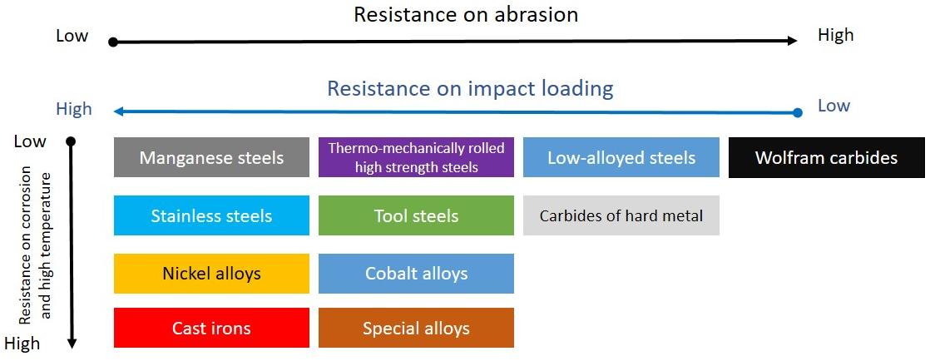
Figure 7: Groups of steel and iron materials

3. Conclusion
A proposed algorithm given and created for easier definition of the base material quality due repair welding of damaged parts aims to solve problems that occur in practice in many cases, concerning the definition of the quality of the basic material. As pointed out in the previous chapter of this paper, the wrong assessment of the base material quality can lead to the wrong welding technology establishment, and thus a poor quality of welded joints with catastrophic consequences. Many damaged parts, on which it is possible to easily perform the repair welding procedure, simply do not have all the defined parameters necessary for performing the repair welding procedure. The algorithm offers solutions to overcome this problem.
Some of the advantages of the proposed algorithm are:
- a simple flow of steps in order to get a proper definition of the basic materia quality of the damaged part
- easier identification of problems due defining the appropriate welding technology
- the possibility of simple and fast establishment of appropriate repair welding technology, which is actually a consequence of the appropriate material quality assessment
- clear overview of necessary and appropriate documentation and equipment as well, in order to define the base material
- the possibility of defining the base material by applying several methodologies of the proposed algorithm.

ACKNOWLEDGEMENT
This work is supported by the Ministry of Education, Science and Technological Development of the Republic of Serbia (Contract No. 451-03-68/2020-14/200135).

REFERENCES

[1] IWE kurs, material, Mašinski fakultet, Beograd 2016.
[2] A. Sedmak, V. Šijački-Žeravčić, A. Milosavljević, V. Đorđević i M.Vukićević, Mašinski materijali, drugi deo, Mašinski fakultet, Beograd, 2000.
[3] Đorđević, B., Sedmak, S., Tanasković, D., Gajin, M., Vučetić, F.: Failure analysis and numerical simulation of slab carrying clamps, Frattura ed Integrità Strutturale, 55 (2021), pp 336-344. doi: 10.3221/IGF-ESIS.55.26
[4] D. Tanasković, B. Đorđević, M. Gajin, M. Aranđelović, N. Gostović, N. Milovanović: Repair welding procedure and techno-economic analysis of burner pipe, Structural Integrity and Life, ISSN 1451-3749 Vol. 21, No. 1 (2021), pp 85–90
[5] D. Tanasković, B. Đorđević, M. Aranđelović, S.A. Sedmak, A. Sedmak, M. Đukić, U. Tatić: Repair Welding of Crane Wheels in Steelworks Smederevo, Advanced Materials Research (Volume 1138), conference: 8th International Conference on Innovative Technologies for Joining Advanced Materials (TIMA 16), pp. 180-185, ISBN 978-3-03835-768-1 (ISSN 1662-8985), June 02-03, 2016, Timisoara, Romania
[6] D. Tanasković, B. Đorđević, M. Gajin, M. Aranđelović, N. Gostović, Damages of burner pipes due to the working conditions and its repair welding, Procedia Structural Integrity (ECF22 - Loading and Environmental effects on Structural Integrity), ISSN: 2452-3216, Volume 13, 2018, Pages 404-409, https://doi.org/10.1016/j.prostr.2018.12.067
[7] M. Aranđelović, N. Milovanović, B. Đorđević, S. Sedmak, I. Martić: Reparation, inspection and damage analysis of steam boiler, Welding and Material Testing, Vol. 3, year XXIX, ISSN 1453-0392, 2020, pp 9-12
[8] Total Materia - www.totalmateria.com
[9] Petronic Sanja Z, Colic Katarina G, Djordjevic Branislav R, Milovanovic Dubravka S, Burzic Meri, Vucetic Filip: Effect of laser shock peening with and without protective coating on the microstructure and mechanical properties of Ti-alloy, OPTICS AND LASERS IN ENGINEERING, (2020), vol. 129. https://doi.org/10.1016/j.optlaseng.2020.106052
[10] D. Tanasković, B. Đorđević, M. Gajin, M. Aranđelović, N. Gostović, N. Milovanović: Repair welding procedure and techno-economic analysis of burner pipe, Structural Integrity and Life, ISSN 1451-3749 Vol. 21, No. 1 (2021), pp 85–90
[11] A. Cabrilo, K. Geric: Weldability of High Hardness Armor Steel, Advanced Materials Research, vol. 1138, Trans Tech Publications, Ltd., July 2016, pp. 79–84. doi:10.4028/www.scientific.net/amr.1138.79
[12] D. Tanasković, B. Đorđević, U. Tatić, S.A. Sedmak, M. Gajin: Cracking Due to Repair Welding of the Treiber Roll, Structural Integrity аnd Life, Vol. 17, No. 2, Belgrade, Serbia, Year 2017., ISSN 1451-3749, pp 133-138
[13] V. Šijački-Žeravčić, G. Bakic, M. Djukic, B. Andjelic: Failures at Elevated TemperaturesThe Challenge of Materials and Weldments, Structural Integrity and Life Assessment, Monograph from 9th Int. Fracture. Mechanics. School, Zlatni Pjasci, Bulgaria, 2008 (Editors: S.Sedmak and Z. Radakovic), doi: 10.13140/RG.2.1.4985.4485
[14] N. Milovanović, B. Đorđević, U. Tatić, S.A. Sedmak, S. Štrbački: Low-Temperature Corrosion Damage and Repair of Boiler Bottom Panel Tubes, Structural Integrity аnd Life, Vol. 17, No. 2, Belgrade, Serbia, Year 2017, ISSN 1451-3749, pp 125-131
[15] M.V. Biezma, U. Martin, P. Linhardt, J. Ress, C. Rodríguez, D.M. Bastidas: Non-destructive techniques for the detection of sigma phase in duplex stainless steel: A comprehensive review, Engineering Failure Analysis, Vol. 122, 2021, 105227. doi: 10.1016/j.engfailanal.2021.105227
[16] Thanh Tuan Nguyen, Hyeong Min Heo, Jaeyeong Park, Seung Hoon Nahm, Un Bong Beak: Damage assessment and mechanical performance of Cr-Mo steel used in hydrogen storage vessels, Engineering Failure Analysis, Vol. 120, 2021, 105031. doi: 10.1016/j.engfailanal.2020.105031
[17] D. Tanasković, B. Đorđević, S.A. Sedmak, M. Aranđelović: The Effect of Exploitation Conditions on the Damage of a Roller Reducer Toothed Shaft and Its Repair, Machine Design, Volume 10 (2018), Number 4, e-ISSN: 2406-0666, pp 157-162, doi: 10.24867/MD.10.2018.4.157-162
[18] Tanasković D., Đorđević B., Tatić U., Sedmak A., Opačić M. : Repair welding of gear shafts of service rollers at Železara Smederevo, 8th International Scientific Conference IRMES 2017 Proceedings, pp 365-370, Trebinje, ISBN 978-9940-527-53-2, September 2017.
[19] N. Bajic, Z. Karastojković: Savremeni postupci navarivanja, istraživačko razvojni centar, IHIS Techno experts, ISBN 978-86-89775-01-03, Beograd 2016.
[20] Drakče Tanasković, Branislav Đorđević, Mihajlo Aranđelović, Simon Sedmak, Aleksandar Sedmak, Miloš Đukić, Uroš Tatić: Repair Welding of Crane Wheels in Steelworks Smederevo, Advanced Materials Research (Volume 1138), conference: 8th International Conference on Innovative Technologies for Joining Advanced Materials (TIMA 16), pp. 180-185, ISBN 978-3-03835-768-1 (ISSN 1662-8985), June 02-03, 2016, Timisoara, Romania
[21] Tanasković D., Tatić U., Đorđević B., Sedmak S., Sedmak A.: The effect of cracks on stress state in crane wheel hard-surface under contact loading, Technical Gazzete, Vol.24 No.Supplement 1, pp 169-175 , ISSN 1330-3651, May 2017. doi: 10.17559/TV-20151227221434‏,.

