EFFECTS OF USING THE MICROSOFT TEAMS PLATFORM AT THE KOSOVO AND METOHIJA ACADEMY OF APPLIED STUDIES

PhD Nenad Marković¹; Dejan Živković¹; Filip Marković²; PhD Sanja Marković¹
¹ Kosovo and Metohija Academy of Applied Studies, Department Uroševac – Leposavić, the Republic of Serbia, nen.mark74@yahoo.com
¹ Kosovo and Metohija Academy of Applied Studies, Department Uroševac – Leposavić, the Republic of Serbia, zile028@gmail.com
² Faculty of Technical Sciences, Kosovska Mitrovica, the Republic of Serbia, ridjikm@gmail.com
¹ Kosovo and Metohija Academy of Applied Studies, Department Zvečan, the Republic of Serbia, sanjamark045@gmail.com

Abstract: The aim of this paper is to show effect of using the Microsoft Teams platform, which served as a tool of communication for teachers, associates and administrative staff in the summer semester of 2020/2021 school year at the Kosovo and Metohija Academy of Applied Studies. The idea for writing this paper arose at the end of the winter semester of 2020/2021 school year, when the Kosovo and Metohija Academy of Applied Studies switched to using the Microsoft Teams platform in communication between teachers, associates and administrative staff. The survey has been conducted after using Microsoft Teams platform in period from December 2020 to June 2021, when teachers, associates and administrative staff presented their experiences and observations that have arisen from this form of communication. Finally, the obtained results were analyzed, and based on them, conclusions were made about advantages and disadvantages of Microsoft Teams platform usage, and values obtained after usage of Microsoft Teams platform at the Kosovo and Metohija Academy of Applied Studies were compared with representative values from the research.

Key words: information-communiciation technologies; Microsoft Teams platform; teachers; associates; administrative staff.

1. INTRODUCTION

Today's society is marked by the rapid growth and development of information and communication technologies (ICT), which in a broader sense has led to a great dependence of society on them. [1] ICTs have a great influence in almost all spheres of human activity and that is why, not without reason, it is said that we live in the information age. The methods of exchange and transmission, as well as the amount of various information, are greater today than ever before in history. [2]
In the last fifty years, technical inventions and technological knowledge have fundamentally changed not only the human environment, but also the ways of human cognition. The Internet as an unavoidable sphere of information events has changed both the way and the dynamics of disseminating information in all areas of society. [3] Digital age and new forms of communication that Internet provides are reflected in various aspects of socio-economic, scientific-research, but also cultural-educational system. Online education, often referred to as distance or online education, is currently the latest, most popular form of distance education. [4]
In 2010, the Republic of Serbia adopted the Strategy for the Development of the Information Society until 2020, which, in part, talks about e-education. The development of the application of ICT in education requires, among other things, the achievement of:
- establishing a modern education system that is adapted to the needs of the information society;
- teacher training for the use of ICT;
- raising the level of knowledge and skills for the use of ICT among the widest population;
- development of the concept of education and lifelong learning; etc. [3,5].

2. USAGE OF MICROSOFT TEAMS PLATFORM AT THE KOSOVO AND METOHIJA ACADEMY OF APPLIED STUDIES

When mentioning the word education, the first thought in today's environment is usage of different types of platforms. Thus, the most common e-learning platform is Moodle, which is used in more than 18,000 educational organizations around the world. [6]
The Microsoft Teams platform is a platform that is part of the Microsoft Office 365 package. It is extremely suitable for the preparation of digital content, for interactive online teaching, exchange of content between users, setting tasks and collecting solutions and answers. The platform allows the use of web applications such as Word, Excel, OneNote, Outlook, Teams, as well as other applications available in Microsoft Office 365, Pic. 1. During the crisis period and the onset of the COVID-19 pandemic, Microsoft provided free use of this platform, which is adapted to the education system. The Microsoft Teams platform is a platform licensed at the Kosovo and Metohija Academy of aApplied Studies
and began to be used at the end of the winter semester of the 2020/2021 school year.

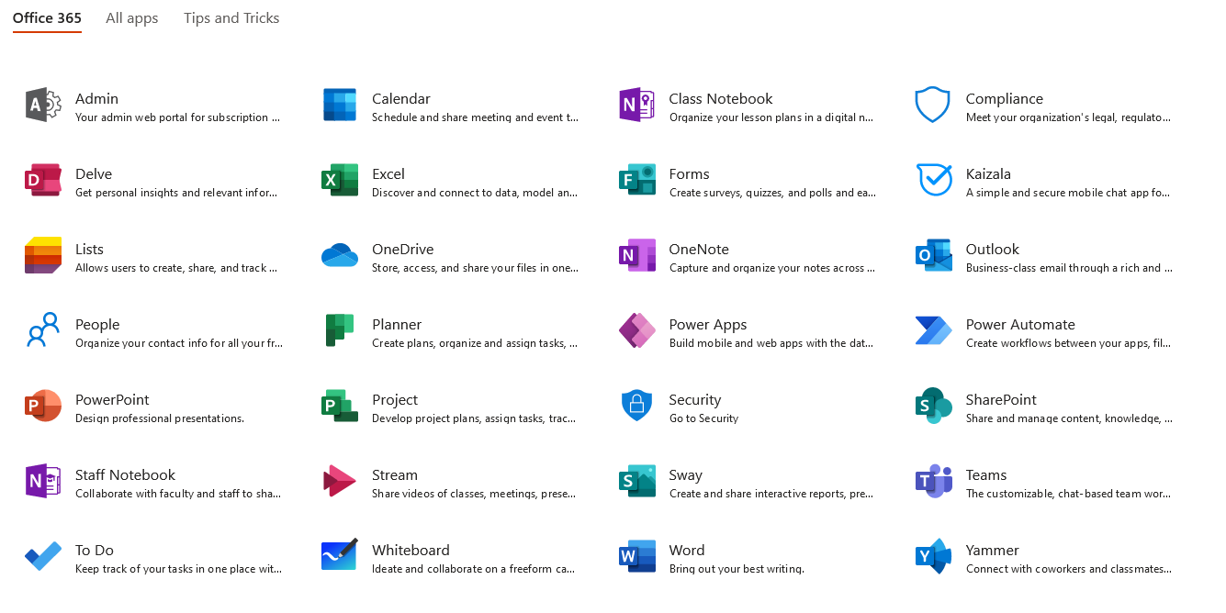
Picture 1: Available applications within MS Offcie 365 package [7]

The Microsoft Teams platform was set up by the administrator of Kosovo and Metohija Academy of Applied Studies and e-mail has been opened to everyone within the platform, which allowed the same to be used in communication between teachers, associates and administrative staff, which gave authors idea to write this paper. The Kosovo and Metohija Academy of Applied Studies decided to use this type of communication between teachers, associates and administrative staff after familiar situation in the country and appearance of COVID-19 pandemic. On this occasion, it is necessary to mention that Kosovo and Metohija Academy of Applied Studies intensively uses the Moodle platform for distant e-learning from the summer semester of 2019/2020 school year.
The research conducted at the end of summer semester at Kosovo and Metohija Academy of Applied Studies is based on an attempt to determine how satisfied teachers, associates and administrative staff are with effects of using the Microsoft Teams platform, as well as to what extent and in which way they used greater number of applications that are available on the same.

3. RESEARCH METHODOLOGY

At Kosovo an Metohija Academy of Applied Studies, a survey was conducted through a questionnaire. The survey was conducted anonymously, where respondents gave answers to the questions asked by circling only one of the few offered answers. The survey questionnaire was compiled on the basis of similar survey questionnaires that were used for this purpose.
The survey questionnaire was created with the aim of being rational (for use and understanding), reliable and structured through questions that do not require too much time to complete. It took 5-10 minutes to complete the survey questionnaire.
Realization of the research: The research of teachers, associates and administrative staff through a questionnaire was realized during the school year 2020/2021 in the period of one month (May 24 - June 25 2021), and on the Microsoft Teams platform a period of six months was observed (December 2020 - June 2021).
Type of research: The research was realized directly through the printed form of the questionnaire.
Sample size: 52 respondents.
Target group: Teachers, associates and administrative staff of the Kosovo and Metohija Academy of Applied Studies. The survey questionnaire contained 14 questions which was composed of two parts. The first part of the questionnaire consisted of 4 questions and contained basic data on teachers, associates and administrative staff (gender, age, department and position at the Kosovo and Metohija Academy of Applied Studies). The second part of the survey questionnaire refers to the use of the Microsoft Teams platform and contained 10 questions.
Applicability of results: The COVID-19 pandemic stopped everyday events for a moment and we all had to adapt to a new way of life. Teachers, associates and administrative staff were “forced” into a new form of communication compared to the pre-pandemic period. This research can be used for further research and comparisons, in educational, professional and scientific terms.

4. THE RESULTS OF RESEARCHES AND DISCUSSIONS

This research started with an idea of involving as many teachers, associates and administrative staff as possible in order to gain a realistic picture in terms of their views and opinions on the effects of using the Microsoft Teams platform. The research on use of the Microsoft Teams platform was conducted on a representative sample of 52 respondents - teachers, associates and administrative staff of the Kosovo and Metohija Academy of Applied Studies. Out of the total number of respondents, 3 survey questionnaires were excluded from the survey, which were not complete.
Of the 52 respondents-teachers, associates and administrative staff whose survey questionnaires were taken into consideration, 73.1% of them were males persons, while 26.9% were females persons, Tab. 1.

Table 1: Number of respondents per gender
Gender | Number of  respondents | Structure  in %
Male persons | 38 | 73.1
Female persons | 14 | 26.9

The age structure of the respondents was 9.6% of the respondents between 25-35 years of age, 42.3% of the respondents between 36-45 years of age and 48.1% of the respondents between 46 and more years of age, Tab. 2.

Table 2: Age structure of respondents
Age  structure | Number of  respondents | Structure  in %
25-35 | 5 | 9.6
36-45 | 22 | 42.3
46 and higher | 25 | 48.1

An overview of respondents by gender as well as their age structure is shown in Diagram 1.

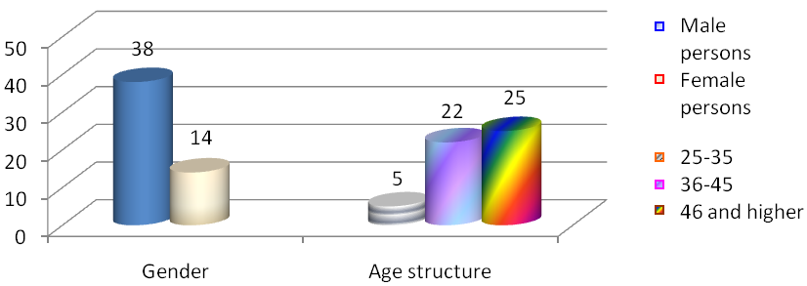
Diagram 1: Overview of respondents by gender as well as their age structure

Table 3 shows structure of respondents per Departments. It is interesting to note that approximately same number of respondents was in all three Departments that are part of the Kosovo and Metohija Academy of Applied Studies, namely: Department Peć – Leposavić, Department Zvečan and Department Uroševac – Leposavić.

Table 3: Number of respondents per Departments
Department | Number of  respondents | Structure  in %
Peć – Leposavić | 17 | 32.7
Zvečan | 17 | 32.7
Uroševac – Leposavić | 18 | 34.6

From the aspect of position that respondents have at the Kosovo and Metohija Academy of Applied Studies, respondent's survey is as follows: 67.3% are teachers, 9.6% are associates and 23.1% are administrative staff, Tab. 4.

Table 4: Position of respondents
Position | Number of  respondents | Structure  in %
Teachers | 35 | 67.3
Associates | 5 | 9.6
Administrative staff | 12 | 23.1

An overview of respondents according to the position they have at Kosovo and Metohija Academy of Applied Studies is shown in Diagram 2.

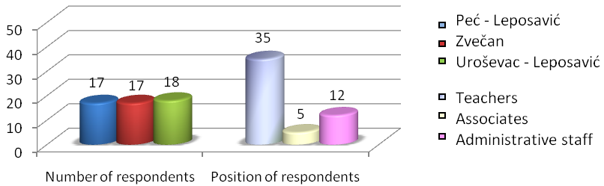
Diagram 2: Overview of respondents per position

Regarding the first part of the questionnaire where 4 questions were analysed and compared with data available to authors in the Administrative Centre of the Microsoft Teams platform at Kosovo and Metohija Academy of Applied Studies [7] we can say that answers are in full agreement with data contained in the mentioned Administrative Centre.
The second part of the questionnaire was designed to deal exclusively with the use of Microsoft Teams platform. From the questions answered by teachers, associates and administrative staff, we will single out a few of the most interesting for this research and analyse them.
Analysing the results of the survey on attitudes and experiences of teachers, associates and administrative staff how satisfied they are with use of Microsoft Teams platform, following conclusions can be drawn:
Analysing answers to question “Do you have experience in using online Microsoft Teams platform?” Over 85% of respondents said they have no experience in using it and about 15% answered that they have already used it.
Analysing answer to question “Are you familiar with the opportunities provided by telecommuting (Microsoft Teams platform)?” Almost 100% of respondents said they were familiar with the opportunities provided by teleworking due to the fact that the Academy of Applied Studies used the Moodle platform to work with distance e-learning students.
Analysing answers to question “Do you use teamwork on the platform (Teamwork)”, 52% of respondents answered affirmative.
Analysing answer to question “Network connectivity is one of the possibilities that the Microsoft Teams platform offers. Do you use file, data, news, resource sharing as part of this action? If the answer is yes, state to what extent you do so?” 86% of respondents stated that they use offered actions within the network connection. Also, all respondents answered that they mostly use activities via email and the OneDrive application.
Analyzing answer to question “What do you think are the positive and what are the negative sides of using the Microsoft Teams platform?” Most respondents said that positive side of using Microsoft Teams platform is that it can be accessed from any space and from any device (desktop computer, laptop, tablet, mobile phone). Respondents pointed out social isolation as the main disadvantage of using the Microsoft Teams platform, i.e. inability to interact between teachers, associates and administrative staff.

5. COMPARISON OF RESEARCH RESULTS WITH ADMINISTRATIVE CENTER OF MICROSOFT TEAMS PLATFORM

Comparing results obtained in the research with results offered by Microsoft Teams platform, it is necessary to point out that results largely coincide. Reports are available for the last 7 days, 30 days, 90 days and 180 days. Data are not immediately available for all reporting periods. Reports become available within 48 hours.
Productivity assessment of using Microsoft Teams platform provides insight into digital transformation of data through the display of different types of applications. Results of the use of Microsoft Teams platform by the Kosovo and Metohija Academy of Applied Studies reflect measurements of technological experience and can be compared with reference values from organizations similar to ours.
Below is an assessment of the productivity (meetings, teamwork and networking) of individual Microsoft Teams platform applications used.

5.1. Meetings

Graph 1 shows the number of online meetings held at the Kosovo and Metohija Academy of Applied Studies in relation to organizations similar to ours. The program provides information that 83% of meetings follow one or more meetings with best practice. This type of communication can save time of over 100 minutes per week.

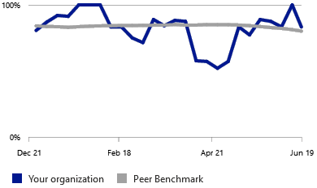
Graph 1: Meetings

5.2. Teamwork

Graph 2 shows a common workspace when users collaborate and share information with each other. This joint cooperation can save up to 4 hours a week. 49% of users at the Kosovo and Metohija Academy of Applied Studies contribute to common workspaces.

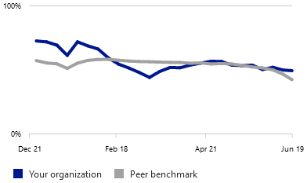
Graph 2: Teamwork

5.3. Network connectivity

Graph 3 shows SharePoint, which encourages teamwork at the Kosovo and Metohija Academy of Applied Studies. The basic role of the same is to share files, data, news, resources. SharePoint provides ability to update network settings to improve user connectivity as well as their use on mobile devices. SharePoint provided insight that over 90% of users use this application (real websites).


Graph 3: Network connectivity
5.4. Total productivity mark

Regarding the total productivity assessment of 6 indicators provided by the Microsoft Teams platform, 3 indicators are presented in the paper. The total productivity score is shown in Graph 4 and is 18% and represents the total number of user experiences and results of technological experiences, which consist of several categories of data. Results are not given at the individual user level. Due to the length limitations, other productivity estimates will be presented in a future paper.

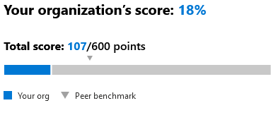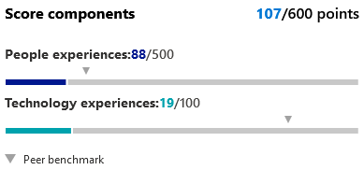
Graph 4: Total productivity mark

5.5. Presentation of other reports (Email and OneDrive)

Reports that will be presented below, show how many users in the Kosovo and Metohija Academy of Applied Studies use services of the Microsoft Teams platform. Graph 5 shows the report in the form of applications that are most used in the Microsoft Teams platform.

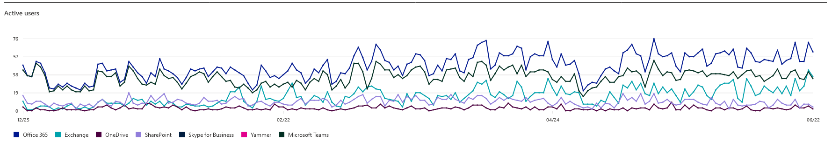
Graph 5: Using applications in the Microsoft Teams platform

The activity via e-mail is shown in Graph 6. The number of actions of sending, receiving and reading messages is shown during the selected time period (period of 6 months). Based on the percentage of usage, we can conclude that this application was mostly used by teachers, associates and administrative staff of the Kosovo and Metohija Academy of Applied Studies.

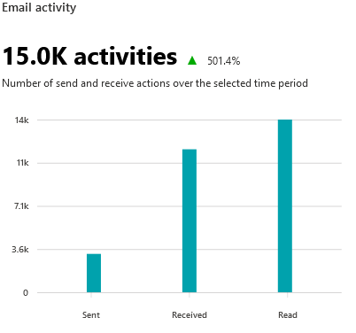
Graph 6: Using e-mail

The OneDrive application (data storage) is the application that was also the most used within the Microsoft Teams platform in the amount of 52.8%. Graph 7 provides an overview of the OneDrive application at the Kosovo and Metohija Academy of Applied Studies, as well as an overview of the use of applications by one of the authors of this paper.

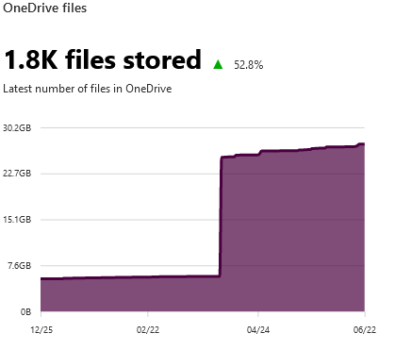

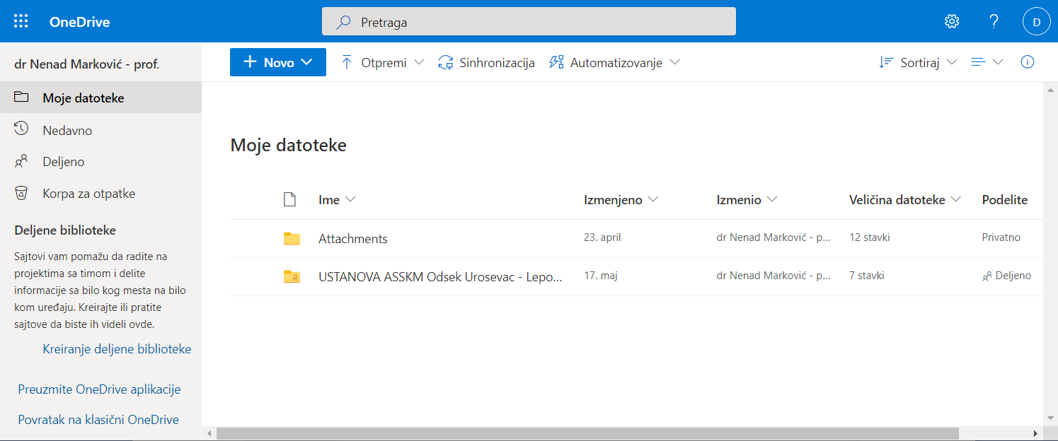
Graph 7: Using the OneDrive application

6. CONCLUSION

The research, conducted on the basis of a survey questionnaire at the Kosovo and Metohija Academy of Applied Studies, show that teachers, associates and administrative staff are satisfied with use of the Microsoft Teams platform, which is used in mutual communication. This once again confirmed the slogan that information and communication technologies are indispensable in today's era of informatics and they have taken precedence in all spheres of education.
Based on previously presented graphs and based on analyzed questions from the survey questionnaire, we can conclude that results of the research conducted at the Kosovo and Metohija Academy of Applied Studies and results obtained from the administrative center of Microsoft Teams platform agree and in principle coincide. Also, based on the expressed satisfaction of the respondents, we can conclude that this type of mutual communication could continue after the end of the pandemic caused by COVID-19.

REFERENCES

[1] Rendulić, D.I., ITdesk.info – project of computer e-education with free access - Manual for digital literacy, Publisher: Open Society for Exchange of Ideas (ODRAZI), Zagreb, 2013., www.ITdesk.info
[2] Sotirović, V., Information Technology, Faculty of Engineering “Mihajlo Pupin”, Zrenjanin, 2004.
[3] Information society development strategy in the Republic of Serbia until 2020. “Official Gazette of RS”, no. 51/2010.
[4] Sadiku, M.N.O., Adebo, P.O., Musa, S.M., Online Teaching and Learning. International Journals of Advanced Research in Computer Science and Software Engineering, Vol. 8, No. 2, 2018, pp. 73-75.
[5] Marković, N., Živković, D., Marković, F., The effects of using the Moodle platform in High Technical School of Vocational Studies from Urosevac in Leposavic, Session 2: IT Education and Practic, str. 219-224, UDC: 37.018.43:004.3, Professional paper, ISBN 978-86-7776-247-6, COBISS.SR-ID 264037900, 18-20. September, Čačak, TIE 2020.
[6] www.moodle.org
[7] Office 365, https://www.microsoft.com/en-au/microsoft-365

