

CURRENT STATUS OF REAL ESTATE CADASTRE IN THE REPUBLIC OF SERBIA IN RELATION TO HISTORICAL CONDITIONS IN DIFFERENT REGIONS OF THE COUNTRY

Spec.Zoran Ilić, Prof.Dr.Goran Marinković, Dr.Jelena Lazić, ing.Marko Božić

Univerzitet u Novom Sadu, Fakultet Tehničkih Nauka, Trg Dositeja Obradovića 6, Novi Sad, Republika Srbija, tel: +381 21 450 810, e-majl : geoingbc@gmail.com
, Univerzitet u Novom Sadu, Fakultet Tehničkih Nauka, Trg Dositeja Obradovića 6, Novi Sad, Republika Srbija, tel: +381 21 450 810, e-majl : goranmarinkovic@uns.ac.rs
, Univerzitet u Novom Sadu, Fakultet Tehničkih Nauka, Trg Dositeja Obradovića 6, Novi Sad, Republika Srbija, tel: +381 21 450 810, e-majl : lazicjelena91@gmail.com
Meixner d.o.o., Zagreb, Hermanova 16G, Republika Hrvatska, e-majl : markobozic@meixner.hr

Abstract:The aim of this paper is to review the current state of the real estate cadastre in the Republic of Serbia based on surveys in 3 parts of Serbia: Vojvodina, as a northern province, central Serbia and southern Serbia, including Kosovo and Metohija. The division into 3 parts was made for historical reasons, because the cadastral plans and the organization of the cadastre have historically been formed on three different principles. These principles were related to the state of the division of Serbia in the past. Therefore, we can talk about the area of ​​the former Austro-Hungarian monarchy, where the Austrian cadastral survey was in force with plans in the scale of 1: 1440, in cities and 1: 2880 in rural areas and outside the construction region. This is the AP area. Vojvodina. In the central part of Serbia during the rule of the Kingdom of Yugoslavia, the survey in the Gauss Krieger projection is 1: 1000 for settlements and 1: 2500 for the suburban region. In the southern part of Serbia, including Kosovo and Metohija, where the tapestry system of cadastre records was in force. In recent years, one of the most important tasks carried out in the RGA is the complex modernization of the real estate cadastre and the implementation of analog cadastral plans in digital form. The paper gives a clear overview of the geodetic documents of the basis for the modernization of the real estate cadastre. A significant part of the paper is the comparison of data results in figures and data in percentages, which characterize the state of improvement of the modernization of the real estate cadastre in certain parts of the Republic of Serbia. The comparison of these results made it possible to formulate the relationship between the current state of progress in the modernization of the Real Estate Cadastre in the republic, as well as the geographical and historical parts of the country for which they were collected.

Keywords: real estate cadastre; vector cadastral map; registry modernization; history of cadastre in Serbia.

1. INTRODUCTION

According to the International Federation of Surveyors (FIG), the definition formulated at the Third Congress in 2011 "Cadastre in Sustainable Spatial Management", Cadastre is a modern land information system based on parcels, which contains records of property rights on land. It usually contains a geometric description of the parcels in relation to other registers describing the nature of these rights, as well as often the values of the parcels and their changes.
In Serbian legislation, based on the Law on Survey and Cadastre: The Real Estate Cadastre is defined as the basic and public register of real estate and real rights to them. Real estates that are registered in the real estate cadastre are:
• land (cadastral parcels of agricultural, forest, construction, water and other land);
• above-ground and underground buildings;
• special parts of buildings that make up the building unit (apartment, office space, garage, etc.) [1]. After the Kingdom of Serbs, Croats and Slovenes was founded in December 1918, there were two main land cadastre systems in its territory, Figure 1. In the northern territory it was the Austro-Hungarian Cadastre and the other part of the Kingdom had no records.

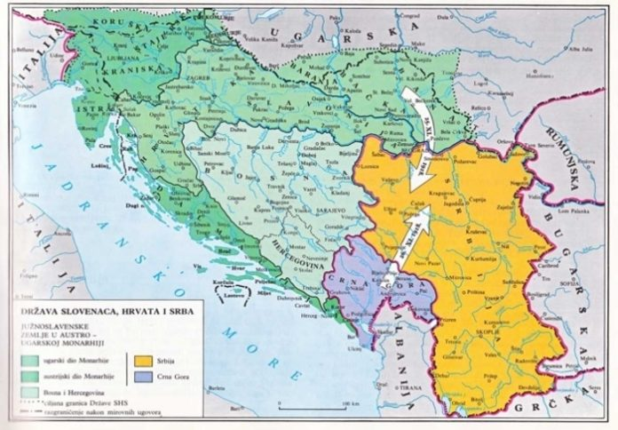
Figure 1: Formation of the Kingdom of Serbs, Croats and Slovenes

The cadastral survey of land in the Republic of Serbia differs according to the time period in which it was created and what method of measurement was applied during field works, ie land survey. In the part of the country whose survey was made in the XIX. century, the graphic method was applied, measurements through a geodetic table, so this form of survey is called a graphic survey. It originated in that part of the Kingdom which in the earlier period was part of the Austro-Hungarian monarchy. In the second part of the Kingdom of Serbs, Croats and Slovenes, which was measured after the First World War, numerical survey methods (orthogonal and polar methods) were applied, and more recently the photogrammetric survey method, so such land surveys are often called numerical surveys.
Cadastral survey of land in our area was performed in several time periods, and cadastral plans were made in various reference systems, so the entire territory of the current Republic of Serbia with regard to existing cadastral plans can be divided into areas:
1. Austro-Hungarian cadastre, part of today's AP Vojvodina (Banat, Bačka and Baranja)
2. Yugoslav Cadastre, part of today's central and southern Serbia with AP Kosovo
The area of the Yugoslav cadastre
The former Yugoslav state, created after the First World War, had a cadastral survey and the institution Land Cadastre only in the area that had been part of the Austro-Hungarian monarchy until then. Serbia, Macedonia and Montenegro did not have cadastral operations, so they joined immediately after World War I. Cadastral survey of unmeasured areas. The survey started first in Serbia in the area of Macva and in the area of the former Ramsko and Golubovac area. However, as the issue of projection had not been resolved until then, the procedure was similar to that of graphic surveys. The survey of the mentioned areas was performed until 1923, and its technical value was not higher than the previous graphic survey. Later, with the formation of the Kingdom of Serbs, Croats and Slovenes, the entire territory was surveyed using classical surveying methods.
Areas of the Austro-Hungarian Cadastre
It refers to that part of the Kingdom that was previously part of the Austro-Hungarian monarchy. It is about today's AP Vojvodina, where the Austro-Hungarian cadastral survey was in force, with plans of scale 1: 1440 for cities and 1: 2880, for villages and suburbs. In some municipalities in Vojvodina, the mentioned plans are still in use today, but they have been converted into digital form.

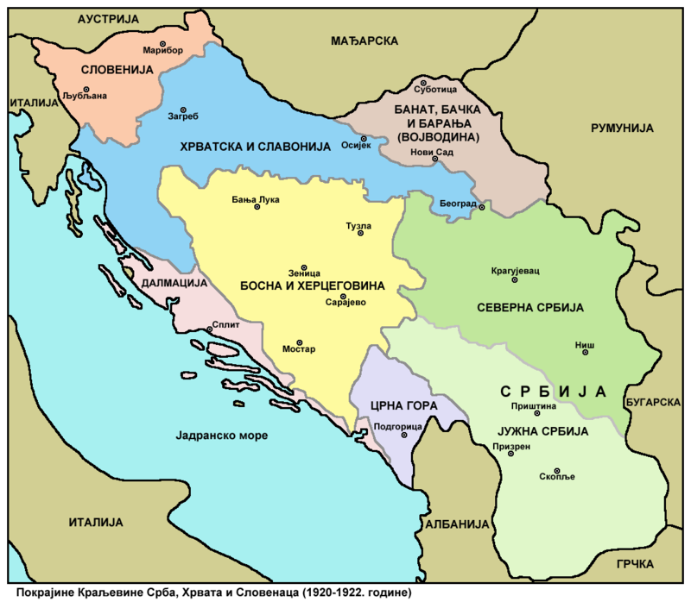
Figure 2: The territory of the Kingdom of Serbs, Croats and Slovenes divided into areas

2. HISTORY OF LEGAL ACTS RELATED TO THE REAL ESTATE CADASTRE IN THE REPUBLIC OF SERBIA

With the unification and creation of a single state of the Kingdom of Serbs, Croats and Slovenes, the Cadastral Service was established and organized. Legislation regulating cadastre management is enacted. The first law that was passed was the "Law on Land Cadastre". It was published in the Official Gazette of the Kingdom of Seba, Croats and Slovenes on 14/1929. Article 1 of the mentioned law defines the preparation of land cadastre on the basis of survey, classification and assessment of land, which will serve as a basis for fair taxation of land and at the same time for the preparation of heritage books. The land cadastre is prepared for each cadastral municipality separately. The boundaries of the cadastral municipalities were determined by the Ministry of Finance, and the deadline for the completion of the land cadastre in the entire country was 10 years. By the end of 1931, a set of laws was passed that completely defined the geodetic profession in the Kingdom.
Since the end of the Second World War, there have been numerous legal regulations in Yugoslavia that regulate the keeping of the real estate cadastre. They will be presented in the order of their appearance:
Decree on the organization of the cadastral service, Government of the Federal People's Republic of Yugoslavia, Official Gazette 4/1948. This decree determines the task of the cadastre and the organization of the activities of the cadastral service. The cadastre is made for the needs of the economy and is maintained in accordance with the actual situation on the ground.
The Decree on the Land Cadastre, adopted by the Federal Executive Council, Official Gazette 43/1953, prescribes the tasks of the geodetic service. These include works on the state survey and maintenance of the existing survey, preparation and maintenance of the land cadastre, works for determining cadastral income over land. The mentioned decree stipulates that all unrecorded areas of Yugoslavia should be geodetically surveyed in the next 5 years. In 1956, the existing Decree was amended. Thus, the new regulation enabled the creation of a census cadastre for a state territory that did not have a technical cadastre.
The Basic Law on Land Survey and Cadastre (Federal Assembly of the SFRY, Official Gazette 15/65) resolved doubts about the technical and census cadastre. This law declares land surveying and cadastre activities to be of general interest for the entire country. The law explicitly stipulates that the survey must be performed so that the obtained data can be used for the state survey and land cadastre. The mentioned law had only 23 articles. According to this law, land survey is performed according to a unique system to determine the data required for horizontal and elevation representation of the terrain of the entire territory of the state, and in order to use these data for economic, technical, scientific and administrative purposes, as well as for other needs of state bodies. other organizations and citizens.
The law on condominium ownership was passed in 1959, when it was adopted by the Federal Assembly of the SFRY. The enactment of this law created the conditions for the registration of condominiums in the land cadastre and land registry. The process of forming geodetic companies began in the 1960s. More precisely, by the decision of AP Vojvodina, the Provincial Geodetic Authority was formed [7].
The Law on Survey and Cadastre of Land from 1971 clearly defines what constitutes a survey of land, starting from the installation of a geodetic network onwards.
It should be noted that in 1988, the Law on the Development of the Real Estate Cadastre was passed in the Republic of Serbia. Later, in 1992, an amendment to the mentioned law was passed, ie harmonization with the new Constitution of the Republic of Serbia was performed. The adopted Law on State Survey and Cadastre and Registration of Real Estate Rights represents the beginning of the introduction of the real estate cadastre as a single record of real estate in the Republic of Serbia
The Law on State Survey and Cadastre (2009) regulates professional affairs and affairs of state administration related to state survey, real estate cadastre, line cadastre, basic geodetic works, address register, topographic-cartographic activity, real estate value assessment, geodetic-cadastral information system and National infrastructure of geospatial data and geodetic works in engineering and technical fields.

3. REAL ESTATE CADASTRE AS A DATABASE

The land registry system, which was abandoned at the end of the last century and which is the basis of the new one, that is, since the real estate cadastre system was made, was in a very bad condition in every sense. The reason for abandoning the old land registry model and moving to the real estate cadastre was the non-functionality, technical equipment and incompleteness of the land registry system, and the inaccuracy of data was highlighted as the biggest problem. More than 70 percent of the territory of Serbia was not covered by the land register, and half of the records were not updated after the renewal of the survey. That is why we moved to the real estate cadastre system, on that occasion all the problems from the old system were taken over. In the process of making the real estate cadastre, in accordance with the then Law, all paper data that could be found at that time were taken over. Owners from the land register who have not been users of real estate in the land cadastre for a long time have been entered in the real estate cadastre, so it started from the very beginning.
In 2011, the Republic of Serbia changed its approach to cadastre management and adopted records called the Real Estate Cadastre. As a country aspiring to membership in the European Union, Serbia has gradually adjusted its real estate records to regulations of the EU Commission Regulation no. 1089/2010 of 23 November 2010 on the implementation of Directive 2007/2 / CoE of the European Parliament and of the Council, as regards the interoperability of spatial data sets and services [2]. So it currently meets all the requirements of the European Union regarding the exchange of spatial data.
The real estate cadastre is a public book or register that represents a database, ie. records on immovable property and rights established on them. The system of real estate records is regulated by law and is based on several basic principles: registration, publicity, trust, legality and the order of registration. Principles are abstract rules that have no direct application, but whose meaning is formulated through specific legal norms and that they give a general picture of the basic postulates on which legal norms are built [3].
The Real Estate Cadastre is managed by the Republic Geodetic Authority, and the public is provided with access to the cadastre via the website. Land (cadastral parcels of agricultural, forest, construction and other land), above-ground and underground buildings, as well as special parts of buildings that make up the building unit (apartment, office space, garage, etc.) are entered in the real estate cadastre.
By registering in the real estate cadastre, rights to real estate are acquired, transferred, limited and terminated. Everyone has the right to inspect the data contained in the real estate cadastre, to be issued a real estate certificate or a certificate that a certain real estate or right is registered in the real estate cadastre.
The real estate cadastre database is a set of geospatial and other data on real estate and real rights to them. It contains data on parcels, buildings, special parts of buildings and holders of real rights to real estate. The database of the real estate cadastre also contains data from the address register and the register of spatial units. A list of real estate for real estate (contains data related to one real estate) and the right holder (contains data related to all real estate belonging to the same right holder) is issued from the real estate cadastre database. The registration of real rights is the registration by which the right of ownership and other real rights on real estate are acquired, transferred, limited or terminated. Ownership of real estate is registered as the right of ownership, the right of co-ownership and the right of joint ownership [4].
Geodetic-cadastral information system consists of subsystems that contain data and data services of basic geodetic works, real estate cadastre, address register, register of spatial units, register of geographical names, cadastre of lines and topographic-cartographic data. Geodetic-cadastral information system provides collection, management, maintenance, access and use of subsystems on the principles of data management in one reference point and enabling access and exchange at different levels; keeping as metadata information about data and services that describe and enable their retrieval; defining data and services respecting national and international standards; enabling external users to access clearly displayed data through a web service; enabling the issuance of documents in electronic or other form; providing services 14 electronic business transactions for the use of data and services that require monetary compensation and providing measures to protect the information system at all stages of operation [4].

3.1 ROLE AND SIGNIFICANCE OF THE REAL ESTATE CADASTRE IN THE REPUBLIC OF SERBIA

The real estate cadastre, as a public register, is one of the most important elements of any social and economic system. Its significance and impact on social relations and the economic system are great, and that is why it is in the interest of both the state and individuals that real estate data be kept accurately and systematically in a single record. The main interest of the state system, ie government bodies, is to have an insight into construction, turnover and other real estate transactions, primarily for legal security, but also for other reasons, which include public revenues.

The real estate cadastre is the basis for economic and spatial planning, assessment, assessment of taxes and other fees, registration of liens and mortgages, public statistics, real estate market and property records. Also, the real estate cadastre is the basic database for the National Infrastructure of Geospatial Data of the NSDI.

3.2 QUALITY OF REAL ESTATE CADASTRE AS DATABASE

The Real Estate Cadastre is considered a state institution of special importance that aims to ensure the legal order and security of land, especially to the extent that it is necessary to unambiguously determine the scope of rights, as well as to provide a sense of legal security. Social expectations, as well as the expectations of service users related to the establishment of the real estate cadastre, unfortunately, do not mean that this register really fulfills all the functions assigned to it. The quality of the collected and entered data in the real estate cadastre, which arises from the adopted legal, legal and technological solutions, confirms the stated assumption. The usual impossibility to unambiguously determine the scope of real estate rights on the ground, as well as the border line between neighboring plots, remains incomprehensible to the public and makes the institution of real estate cadastre lose its significance.

4. PROGRESS AND MODERNIZATION OF THE REAL ESTATE CADASTRE

Achieving significant improvement in the state cadastral system requires an adequate state policy in land information management. However, in order for such an improvement to be achieved, the way the current system works must be reviewed and analyzed. This includes determining the current state of rights and data affecting land parcels and identifying legal, physical, administrative and social constraints affecting the development of a permanent cadastral system. Technical aspects of cadastral information systems include the determination and delimitation of boundaries, conducting research and description of parcels and records.
- KN database covers the entire territory of RS:

- Alphanumeric data - are maintained in digital form throughout the RS,
- Spatial data - are maintained in digital form on 100% of the territory of RS;

The real estate cadastre database contains data on:
- Plots (alphanumeric data - 18.932064)
- Plots (spatially referenced - 12,162,902),
- Objects (alphanumeric data - 4,697,852)
- Facilities (spatially referenced - 3,093,463),
- Special parts of buildings (total number 1,020,275), [5].

Based on the presented data, we can conclude that part of the data recorded in the real estate cadastre database contains partly data on the basis of surveys, and partly data obtained by scanning and georeferencing old plans, which are used in maintaining surveys. The given data refer to cadastral parcels and facilities. The data presented are on the digital cadastral plan.
The digital cadastral plan forms the basis of the cadastral information system.
The Law on State Survey and Cadastre in Serbia [6] defines that the Geodetic-Cadastral Information System consists of subsystems containing data and data services of basic geodetic works, real estate cadastre, address register, register of spatial units, register of geographical names, line cadastre and topographic -cartographic data [6].
Due to some limitations in the scope of this study, the comparison will be limited to the graphic part of the land register, ie to the digital cadastral plan. As shown in Table 1, there are significant differences between urban and rural areas. In urban areas, the status of modernization is far higher. This trend refers to the entire territory of the Republic of Serbia.

Table 1: Cadastral digital plan in Serbia
Cadastral topographic plan | Urban areas | Rural areas
Cadastral map in vector format | 74% | 61%
Cadastral map in raster format | 26% | 39%

4.1 AUTONOMOUS PROVINCE VOJVODINA

A digital cadastral plan has been developed for almost the entire province. For a certain part of cadastral municipalities, the digital plan was developed on the basis of original survey data, and part on the basis of scanned cadastral plans, which is also shown in Table no. 2

Table 2: Cadastral digital plan Autonomous Province of Vojvodina
Cadastral topographic plan | Urban areas | Rural areas
Cadastral topographic plan obtained on the basis of original survey data | 66% | 67%
Cadastral topographic plan obtained on the basis of scanned plans | 34% | 33%

4.2 CENTRAL AND SOUTHERN SERBIA

A digital cadastral plan has been developed for almost the whole of central and southern Serbia. For a certain part of cadastral municipalities, the digital plan was developed on the basis of original survey data, and part on the basis of scanned cadastral plans obtained by the photogrammetric recording method. which is also shown in table no. 3

Table 3: Cadastral digital plan Central and Southern Serbia
Cadastral topographic plan | Urban areas | Rural areas
Cadastral topographic plan obtained on the basis of original survey data | 78% | 69%
Cadastral topographic plan obtained on the basis of scanned plans | 22% | 31%

4.3 KOSOVO AND METOHIJA

In Kosovo and Metohija, the survey was completed on the entire territory, that is, in 1,298 KOs, with an area of 1,090,812 ha. The analysis of the digital cadastral plan for the territory of the Autonomous Province of Kosovo was not done because the analogous plans were not even digitized. The southern Serbian province, Kosovo and Metohija, has been under the jurisdiction of the United Nations since 1999, in accordance with UN Resolution 1244.

5. CONCLUSION

In conclusion, it should be emphasized that the progress of modernization of the real estate cadastre in the Republic of Serbia is a comprehensive process that is going in the right direction. The fact is that it takes a long time to build on what has been missed in the past and bring the real estate cadastre in the Republic of Serbia to approximately good condition, like the cadastre of European Union countries.
One of the elements of the modernization of the real estate cadastre is certainly the digital cadastral plan, ie the conversion of analog cadastral plans into digital ones. Based on the performed analysis, it can be concluded that the Republic of Serbia shows a high degree of progress in its development for the entire territory. `
In the presented comparison, we can conclude that central and southern Serbia have the highest quality digital cadastral plan in terms of data accuracy. This situation is expected considering that the research in that part of Serbia was done by classical and photogrammetric recording methods. Part of today's Vojvodina leads in the quality of surveys, but only for those cadastral municipalities in which there is a new survey. Where research and consolidation have been renewed, the coverage percentage is 78%, but the other part of 22% is old Austro-Hungarian research, which is almost unusable. The state of the digital cadastral plan for the territory of AP Kosovo is not considered in this paper because currently AP Kosovo is under the jurisdiction of the United Nations.

LITERATURE

[1] Zakon o državnom premeru I katastru, [2] Uredba Komisije EU br. 1089/2010 od 23. novembra 2010. o sprovođenju Direktive 2007/2 / VE Evropskog parlamenta i Saveta, u pogledu interoperabilnosti skupova i usluga prostornih podataka,.
[3] (https://datainvestment.rs/blog/znacaj-katastra-nepokretnosti/)
[4] Aleksandra Radulović, Model domena i servisa u geoinformscionom sistemu katastar nepokretnosti, Doktorska disertacija,Novi Sad 2015 [5](https://www.rgz.gov.rs/) [6] Zakon o državnom premeru i katastru, ttp://www.rgz.gov.rs/web_preuzimanje_datotetka.asp
[7] Geodetska delatnost u Srbiji 1837-1947-1987.monografija , Bgd 1987.

