RE-IMAGINE HIGHER EDUCATION – COMPETITIVE SKILLSET NEEDS FOR POST “COVID-19” IN-PERSON LEARNING DELIVERY

Maja Jovic, M.Ec.
Independent Scholar, Edmonton, AB, CANADA maja.m.jovic@gmail.com

Abstract:
In preparation for the next school year, educational institutions are contending to incorporate pre-COVID 19 practices with the experiences gained while struggling to deliver education to its students during COVID 19 disruption to best perform in the upcoming “new normal”. This article reveals vulnerabilities and challenges that educators and students faced during these unprecedented times; it also offers insight into emergent skills that were most effective in proactively responding to the changes faced in the previous year. Furthermore, this paper introduces skills which enabled the student-facing educators to respond to this change and re-imagine face to face pedagogies. The paper recapitulates facts of preceding educational models which sometimes steered toward reactive content delivery — answering to arising fluctuations as they came. These insights reignited the benefits of proactive thinking by revisioning in-person delivery and skills that educators need to appropriately lead these conversations.

Keywords: change management, COVID-19 in education, disruption, resilience, empathy, agility

INTRODUCTION
The unprecedented event that marked year of 2020 disturbed all aspects of life worldwide. The occurrence and fast spreading of COVID-19 virus throughout the world has caused volatile context effecting the social, economic, and political settings. Education has not been left out; in April 2020, 193 countries reported closures of national level schools and higher education institutions as governments attempted to contain the spread of the virus [2]. This has resulted in hasty transfers to online and remote teaching in colleges and universities around the world, in what is possibly the largest unplanned educational experiment ever instigated. Although the COVID-19 situation in education has revealed many vulnerabilities, it has also surfaced extraordinary human resourcefulness and potential. This was a time for both practical and quick actions.
In the last few centuries, education mainly revolved around students and teachers in standard face-to-face delivery models. In the last several decades, rapid technological advances moved toward online teaching and learning experiences. Despite these advances, the standard education model still relied heavily on in-person learning. This approach enabled educators to connect with their students on a more individual level, gain better understanding of the student’s needs, and build better support systems for them. The widespread school shutdowns disabled teachers from providing these supports to students while also preventing students from accessing supports. This disturbance has not only caused more stressful situations for students, but also the need to navigate the changes in their lives due to pandemic restrictions.
This paper will summarize the challenges that emerged during pandemic restrictions, as well as share the skills that educators found most invaluable while battling the aforementioned disparities in content delivery.

PRE-COVID PRACTICES
Traditional methods for curriculum delivery are well-established, thoroughly vetted, and apply deep pedagogical principles and processes to deliver the best outcomes for students. There are multiple generations of students who have learned under these methods and have grown to be creative and productive members of our society. These methods must be taken into consideration while deliberating changes in teaching practices. One essential skill identified in more recent years is information literacy. Information literacy is “the knowledge, the attitudes, and the sum of the skills needed to know when and what information is needed; where and how to obtain that information; [and] how to evaluate it critically and organize it once it is found; and how to use it in an ethical way” [3]. To successfully incorporate information literacy, three traits identified to be most effective, according to Instructional Design and Research Strategist Michelle Schwartz, are teaching competencies, relationships with students, and teacher attitude [15].
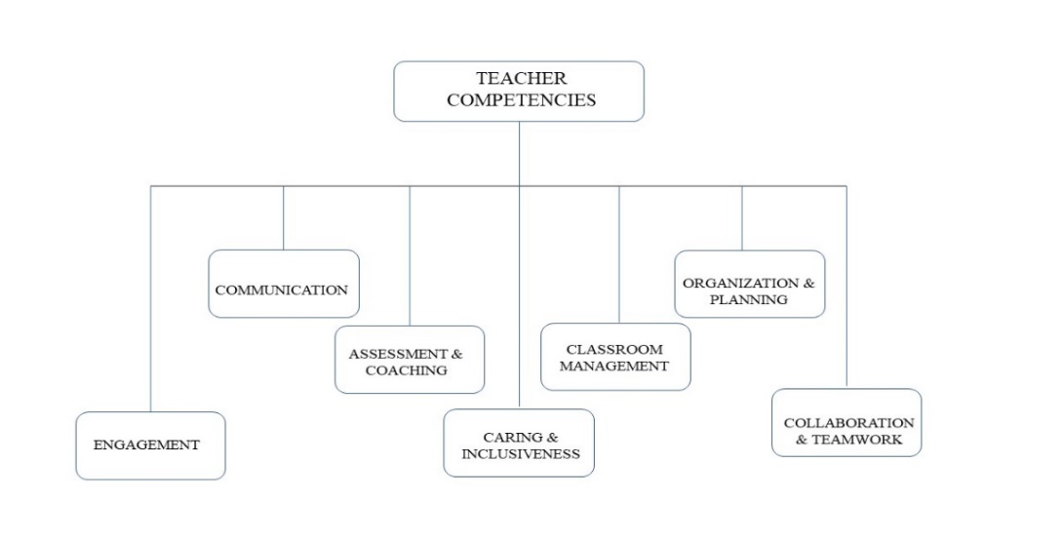
Picture 1. Teacher Competencies, Abbotsford School District 2020.
When referring to teacher competencies, it is important to acknowledge their respective skills. Aside from providing relevant and real-time information, adult learners are appreciative of instructors who are able to structure classroom learning, implement a variety of teaching techniques, and stimulate discussion [3]. Each class taught requires thorough organization and planning while ensuring clarity of communication and interpersonal skills. The ability of an instructor to connect with a student advances effective learning environment where all individuals involved learn from each other. Students learn a particular subject from a teacher, while the teacher learns how to improve their teaching skills. The teacher makes their lessons more interesting by gaining insights from their students. These symbiotic relationships rely on both parties’ familiarity with physical classroom dynamics. In this dynamic, a teacher is able to assess the room, and recognize students who: quickly grasp concepts; take an active part in the learning process; are shy or uninterested; or are even disruptive. Teachers have a responsibility to create classroom atmospheres which encourage motivated learning processes. The ability to create caring and inclusive environments is a primary marker of success in classroom management. To enhance teacher-student relationships, teachers constantly improve their accessibility, approachability, and understanding of students’ needs outside of the classroom. Adult learners value teachers who are flexible and sympathetic toward students’ life experiences even outside of the classrooms. A teacher who shows enthusiasm and expresses a fun attitude will gain the appreciation and support of adult learners over those who do not [3].

CHALLENGES OF MOVING IN-PERSON CLASSESS ONLINE
Most of teachers’ experience occurred during calm and predictive times. Faculty researched and improved practices in order to deliver material through methods that exemplified sound pedagogy and clarity of communication. This all changed at the beginning of 2020 with the COVID-19 pandemic. Our understanding of “urgency”, “importance”, as well as “best practices” have all changed. The disruption that the pandemic brought into our lives exposed many vulnerabilities in our society and is still having a profound impact-not only on people’s health, but also on how students learn, work, and live. Among the most important challenges created by COVID-19 is how to adapt a system of education built around physical schools [5]. Closures have had a very real impact on all students, especially on those most vulnerable, who are more likely to face additional barriers. These are students who may be considered low-income, immigrants, refugees, visible minorities, Indigenous, outside gender norms, and those with special education needs. Students suffer as they are being deprived of physical learning opportunities and the social and emotional supports available in schools. They risk falling further behind and becoming more isolated while school doors are closed. If countries take insufficient measures to promote educational equity and inclusion, these vulnerable student populations stand to lose the most in terms of their education and the support provided by schools. Though many post-secondary institutions offered online course delivery long before this disruption, students had an option between face to face or virtual learning. Only students well-equipped with a stable internet connection and compatible technology would have chosen an online approach. The pandemic resulted in a hasty switch to online classrooms which left many students behind. With online learning being the only option, students ran into several major issues; the most commonly discussed issues encountered by students included limited access to quiet working spaces, lacking access to necessary tools or technologies, a lack of social connection or sense of belonging (school community), and novel, intensified mental health issues.
3.1 Limited access to physical working spaces
This is a major problem for students living in poverty worldwide who often rely on the physical setting of their schools to provide a positive environment to learn and work. In their homes, especially during times of confinement or quarantine, individuals can face multiple forms of abuse and violence [7]. Crowded conditions and a general lack of resources mean that the cost—in terms of education and general well-being—of the current health crisis will be highest for vulnerable populations. Also, with internships and apprenticeships cancelled, technical and vocational education programs shut down, and community centers closed, it is those who had the least resources to begin with who are harmed the most. Furthermore, these circumstances heavily affected their mental health.

3.2 Lack of appropriate tools and technologies
To utilize school time effectively during the unexpected shift to online education, in March of 2020 most schools developed web portals for students to access from home where they could attend synchronous online classes, or, where synchronous was not an option, asynchronous options and even a dedicated TV channel [2]. However, many households still struggled with access. Households experiencing financial hardship were restricted to accessing the Internet solely via mobile plans. Mobile plans have download limits, which, once exceeded, incur additional costs [6]. To address the digital divide during the pandemic, many countries recognized the necessity of a variety of media supports for student learning during school closures. Since March 2020, countries have adopted different strategies to support learning. For example: in Portugal, the government endorsed a partnership involving schools and post office services to ensure timely delivery of hardcopy learning resources to homes; the New Zealand government provided educational content via two television channels combined with learning resources available in both hard and soft copy formats. In addition to differing teaching modalities, several countries have implemented loans of electronic equipment such as laptops or tablets [6]. Despite the conjecture that young people know how to use technology, many school-age learners do not have high levels of confidence in using digital platforms for learning or may not have the necessary skills to use technology in critical ways. Students who are able to selectively access and assess technology content, that is, to use technology critically, are also more likely to be students from more materialistically resourced backgrounds. Furthermore, with the increased use of technology for online learning during the pandemic, there may be greater exposure to inappropriate material and increased risk of cyberbullying.
3.3 Lack of sense of belonging
As previously mentioned, one of the basic teacher competencies is engagement. Within the school community, the teacher–student relationship most often forms the basis for student engagement. Face-to-face teaching nurtured all three components of student engagement--behavioral, emotional, and cognitive--which were all impacted during mass school closures. Positive face-to-face interactions with teachers and peers at school is an integral part of students’ learning. When students work collaboratively in a school environment with a well-developed sense of their own voice, they can expand their knowledge through positive cognitive and emotional interactions [6]. Disengaged students experience adverse academic and social outcomes, including lower achievement and disruptive behavior. Students from disadvantaged backgrounds are reported as being more likely to experience indicators of disengagement, such as daily absences, disruptive behaviors, and poor school connectedness [8]. Losing the school’s community and being denied the opportunities to share and exchange thoughts and experiences with peers immensely affected many college students.
3.4 Intensified mental health issues
The shift to online learning uncovered that supporting students’ social and emotional well-being is an imperative. Although some students attributed technology usage to their online learning issues, emotional challenges associated with the online environment also arose. The emotional consequences related to school closures were at its highest peak: anxiety disorders, as well as common mental, emotional, and behavioral problems among young students were increasing at alarming rates. Further implications of learning off-site relate to individual students’ emotional safety; schools provide a safe and nurturing haven for many students and the physical and social isolation denied them this emotional shelter. Proactive emotional support for individuals most impacted by this situation involves managing emotional, financial, and logistical challenges in a multisystem approach across the community to support vulnerable families [10]. The multisystem mobilization that occurred between schools and their communities during the COVID-19 pandemic was able to offer support to vulnerable families and highlights the importance of addressing psychosocial challenges associated with the changes resulting from the pandemic. It further recommends that these steps take priority over teaching, describing a necessity to "ensure regular human interactions, enable social caring measures, and address possible psychosocial challenges that students may face when they are isolated" [7].

REVAMP OF IN-PERSON LEARNING DELIVERY
The current environment and recent events remind us that both educators and industry need to constantly be alert, attentive, and proactively adjust. In the COVID-19 era, when the whole world experiences novel circumstances, many educators had a revelation of the most effective way to meet the outcomes.
4.1 Empathy
Empathy provides students the ability to lead meaningful, productive lives. From a psychological standpoint, this is called the "empathy advantage." Empathy helps us both understand and feel with others. Forbes Magazine urges companies to incorporate empathy and perspective-taking principles; the Harvard Business Review named empathy as one of the "essential ingredients for leadership success and excellent performance" [24]. Many classes were either shifted online or re-written into self-paced, self-study courses. Once we are back into personal interaction with our students, it will not be imperative to use the “proper” approach in solving a certain problem. It will be to understand how the process affects them. Recognizing that students need more than academic consistency and test prep to succeed, a growing number of schools are turning their focus to social-emotional qualities - empathy. Empathy is at the core of everything that makes a school caring, a teacher responsive, and a society civilized. Teacher’s empathy is the degree to which an instructor works to deeply understand students’ personal and social situations, to feel care and concern in response to students’ positive and negative emotions, and to respond compassionately without losing the focus on student learning [23]. Showing empathy encourages people to strive for more, to be more resourceful and even to be more resilient.
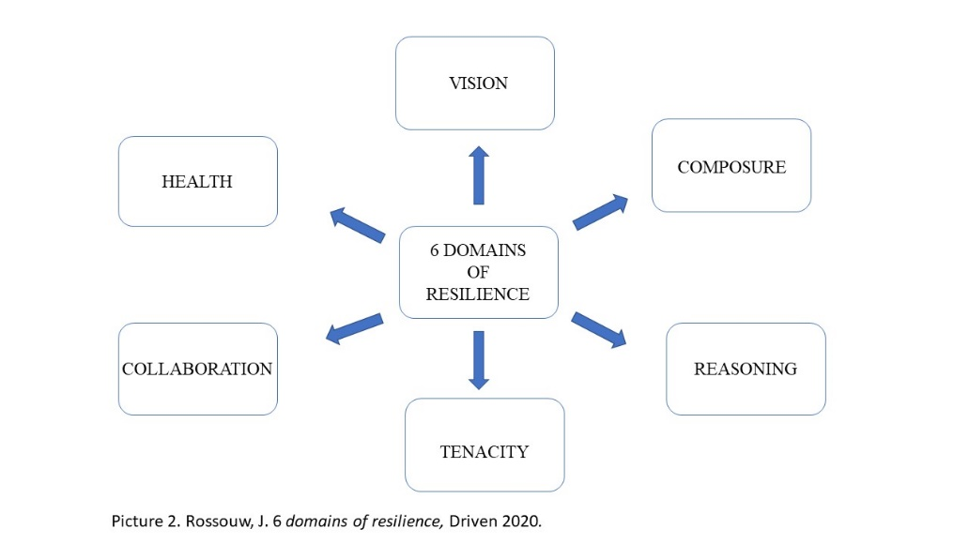

4.2 Resilience
Resiliency can be viewed through 6 different aspects: vision, composure, reasoning, tenacity, collaboration and health [21]. Vision is recognized by research as the most influential in a process of building positive relationships through caring, social justice and equality, integrity, honesty, responsibility and restraint. It also is a foundation for developing every other aspect of oneself. It helps us recognize our own purpose and goals [21]. This leads us to the second aspect – composure. In order to recognize strengths and be compatible, one of the most important skills an individual can have is emotional regulation. Composure helps us to make sound, thought-through decision, without becoming emotional which would prevent us from properly accessing our ability to think critically. This refers to interpersonal competence, communication, respect and ability to actively listen. All of these aspects are building a solid social competence every individual, especially an educator, needs. In order to be useful and resourceful, one needs to be socially competent. Reasoning – Reasoning can only be applied if a person has a developed sense of vision and composure. it’s not just about applying critical thinking during a crisis, but also about taking action ahead of time to prevent things from going wrong in the first place. During in-class discussion times, educators were able to identifying student’s interests, standpoints and understand their opinions. Students who leave a class with a notion and feeling they’ve learned something different and new while questioning their own pre-conceived notions is the best way to establish ones’ own critical reasoning. All of these skills put together and utilized in a day-to-day life creates tenacity. This expresses one’s ability to recognize the need to stay with the problem longer in order to learn more about it or achieve something new. The success lies in repetition, through which we master a skill. Not giving up, believing in a better second attempt will bring results. Every time we try to make something and fail, should be observed from a standpoint of “learning an approach that doesn’t work”, rather dwelling on a fact that we’ve failed. The most useful for success is to have a sense of ‘realistic optimism’, meaning that you are hopeful about your ability to succeed, but you realize that the road will be tough and full of challenges. This realization combined with the willingness to be persistent is what ultimately leads to success for individuals, teams and organizations. These recoveries of their own selves, learning different strategies, improving and increasing their competences is all part of the collaboration aspect in ones’ life, as it is the only pathway to growth. We are all social beings and we need interaction with others, for reasons of bouncing off our ideas off of others who might have a different understanding and also to learn from others about their experiences. Education, as a process of gaining knowledge, does not only include learning new information from books – it is an experience of improving your own interpersonal skills, abilities to recognize your own faults and act on it and continuously searching for a better approach. To utilize this, we need others. One of the most valuable skills one can develop is being able to know what behavior is best in different contexts so you can keep things constructive and build positive relationships. Health is the essential aspect of everyone’s lives. If we don’t take care of our bodies and minds, we will not be able to grow and develop any of the aforementioned skills. Mental health and physical health are our driving forces – it is only logical to take care our ourselves first, so that we can be of value to others. During the COVID-19 chaos, one of the first issue people came across, beside emergency change is mental health. This was and still is, one of the most discussed aspects of everyone’s lives, as we’ve witnessed what we’ve known for a long time, that we are human and social beings and our ability to cooperate and interact plays a big role in our mental health. That, furthermore, bring us to the next skill, invaluable in the whole process of education and life in general.
4.3 Agility
By its definition, agility refers to ones’ ability to react quickly and easily. In higher education, in a research conducted at six public colleges, it was identified that agility was a reason for increased student engagement, encouraged students who took responsibility for their learning, enhanced level and quality of collaboration and higher quality of deliverables [25]. In an agile environment, workplace teams place a heavy emphasis on collectively articulating their goals, frequently reflecting upon and adjusting work plans, facilitating authentic group interactions, improving team dynamics and encouraging experimentation and innovation [26]. Agility plays a key role in building an informed framework and ability to critically approach issues and discussions. It creates a competitive advantage that can be optimally sustained with innovation and quality. An agile organization synchronizes processes and procedures with advanced technology, and addresses clients’ needs based on quality products and services within a shortest time possible. This allows the businesses to stay competitive and continue providing excellence to its clients. The same goes for higher education institutions. As the changes brought on by COVID-19 disorder required agility of everyone, our abilities and the wisdom we have obtained from experiences were put to test. It was expected of everyone to apply knowledge in order to take successful action in new, unfamiliar situations. Flexibility is the ability to observe things from various angles and to put forward ideas in the midst of changing, still unknown directions. Adapting included changes in content, products and services in order to stay afloat and understand and foresee the upcoming stages. This was only possible with a strong sense and skill of agility.

CONCLUSION
Uncertain times call for uncertain measures. Up until now, curriculum design was a fairly straightforward process. Given the sudden necessary measures population undertook in order to stay afloat during the Covid-19 shut-downs, educators realized that this is the moment where schools should take advantage of revamping their curriculum in order to fulfill newly established industry’s needs and to strengthen the connection between schools and market needs. During the disruption that COVID-19 brought upon us, quick thinking and unusual flexibility were required whilst operating under conditions of uncertainty and fear. The ambiguity of the environment we’ve suddenly found ourselves in, called for extreme resilience and agility. Looking back at the responses of the higher education institutions, only the ones who were quick to accept disturbance and find ways forward, managed to stay afloat. Even though many institutions have had in their offers distance or online learning, we have learned that these unprecedented months behind us called for entirely new approach: re-vamped skillset and approach to recognize individuals who would be able to proactively deal with changes, empathetically respond to adversity of the surrounding in order to resiliently find ways forward. The switch to diversified online learning should be considered as an opportunity to integrate industry into learning process and create partnerships and work integrated learning. Industry partnerships and work integrated learning will offer additional source of funding to help alleviate these gaps to learning, and further bolster education. This would create benefits for students as they now have access to work and industry experience, while it would help educational institutions to provide a more holistic and complete education for their students. Furthermore, this industry inclusion would provide business with an opportunity to offer guidance in learning and mold their next generation of workers.

6. REFERENCES:
[1] Arendt, H. The crisis in education. In H. Arendt, Between past and future (pp. 170-193). New York: Penguin Books (2006/1954)
[2] UNESCO, https://en.unesco.org/news/one-year-covid-19-education-disruption-where-do-we-stand accessed on 5/8/2021
[3] Schwartz, M. Information Literacy: Essential Skills for 21st Century Learning, Society for Teaching and Learning in Higher Education Conference 2012.
[4] Lee, K. Timeless Elements Of Strong Student-Teacher Relationships, accessed on 05/26/2021 https://www.teachthought.com/technology/4-timeless-elements-strong-student-teacher-relationships/
[5] OECD: The impact of COVID-19 on student equity and inclusion: supporting vulnerable students during school closures and school re-openings, 2020
[6] Drane, C. Vulnerable learners in the age of COVID-19: A scoping review, National Centre for Student Equity in Higher Education, Australia 2020
[7] UNESCO: Education in a post-COVID world: Nine ideas for public action, United Nations Educational, Scienti c and Cultural Organization, 2020.
[8] Hancock and Zubrick, Children and young people at risk of disengagement from school. Subiaco: Commissioner for Children and Young People, 2015
[9] Kowalczuk-Waledziak, M etal., Rethinking Teacher Education for the 21st Century, Barbara Budrich Opladen, Berlin & Toronto 2019
[10] Motti-Stefanidi, F., Resilience among immigrant youths: Who adapts well, and why? Current Directions in Psychological Science 2019.
[11] El Masri, A, Sabzalieva, E, Dealing with disruption, rethinking recovery: Policy responses to the COVID-19 pandemic in higher education, Policy Design and Practice, 3:3, 312-333. (2020)
[12] Education in the time of COVID 19 and beyond, Stanford Graduate School of Education 2021
[13] Perrotta D., Universities and Covid-19 in Argentina: from community engagement to regulation, Studies in Higher Education, 46:1, 30-43, 2021.
[14] Peters et al., Reimagining the new pedagogical possibilities for universities post-Covid-19, Educational Philosophy and Theory, 2020
[15] Schwartz, M., Engaging Adult learners, Instructional Design and Research Strategist, Toronto, Canada 2013.
[16] Day et al., The Immediate Impact of COVID-19 on Postsecondary Teaching and Learning, The Professional Geographer, 73:1, 1-13 2021
[17] Tarc, P. Education post-‘Covid-19’: Re-visioning the face-to-face classroom, Current Issues in Comparative Education (CICE) Volume 22, Issue 1, Special Issue 2020
[18] Teaching Competencies, Abbotsford School District 2020
[19] Curtin, R. Reimagining Higher Education: The Post-Covid Classroom, EDUCAUSE Reviews, Microsoft (2020)
[20] Factors influencing organizational agility in higher education, accessed 5/8/2021https://www.emerald.com/insight/content/doi/10.1108/BIJ-04-2020-0151/full/html
[21] Rosouw, J., Six Domains of Resilience, Driven 2020
[22] Borba, M. Nine Competencies for Teaching Empathy, Educational Leadership 2018.
[23] Meyers &Rowell, Teacher Empathy: A Model of Empathy for Teaching for Student Success, 2019.
[24] Goleman, D., What makes a leader? Harvard Business Review OnPoint, 2014
[25] Krehbiel C., et al. Agile Manifesto for Teaching and Learning, The Journal of Effective Teaching, 2017.
[26] Smith, S., & Sidky, A., Becoming agile…in an imperfect world. Greenwich, CT: Manning Publications Co. 2009.
[27] Drew, H. Learning Agility in Education: Analysis of Pre-Service Teacher's Learning Agility and Teaching Performance, Institute of Education Sciences, 2017.
[28] Nissim, Y. et al., Agility in Teacher Training: Distance Learning During the Covid-19 Pandemic, Canadian Center of Science and Education, 2020.
[29] International Commission on the Futures of Education. Education in a post-COVID world: Nine ideas for public action. Paris, UNESCO (2020)

